

MASTER’S IN BIG DATA

Predicting Novel Drug Metabolism with Machine Learning: A CYP450-Based Approach

Master's Thesis by: Gonzalo Robles Criado
Thesis Supervisor: Juan Manuel Moreno Lamparero

– Madrid, August 2025 –

Abstract
Drug metabolism mediated by cytochrome P450 (CYP450) enzymes plays a central role in drug safety and efficacy, yet experimental identification remains costly and is often deferred until late-stage development. This work presents a reproducible machine learning benchmark for predicting CYP450-mediated metabolism using a curated dataset of 1,368 drug-like compounds annotated against 13 CYP450 isoenzymes. Four molecular representations (Morgan fingerprints, MolE, ChemBERTa, and embeddings from a self-trained transformer 1.5 million InChI strings) were used as inputs to Logistic Regression, Random Forest, and XGBoost under a common framework using multilabel-stratified partitioning, hyperparameter optimisation, and an independent test set. Molecular representation had a greater impact on predictive performance than classifier choice; Morgan fingerprints and MolE consistently outperformed ChemBERTa and the InChI-based embeddings. The exploratory InChI model demonstrated that chemically meaningful representations can be learned directly from InChI strings even under substantially limited pretraining resources. Overall, this study provides practical guidance for molecular representation and model selection in CYP450 prediction, supporting the use of machine learning as a decision-support tool for prioritising compounds for experimental metabolism studies.

Resumen
El metabolismo de fármacos por parte de citocromos P450 (CYP450) desempeña un papel central en la seguridad y eficacia de los medicamentos, sin embargo, su identificación experimental sigue siendo costosa y a menudo se pospone hasta fases avanzadas del desarrollo. Este trabajo presenta marco de referencia reproducible de aprendizaje automático para predecir el metabolismo mediado por CYP450 utilizando un conjunto curado de datos compuesto por 1,368 medicamentos con anotaciones frente a 13 isoenzimas CYP450. Cuatro representaciones moleculares (‘Morgan fingerprints’, MolE, ChemBERTa y embeddings de un transformador propio entrenado en 1.5 millones de cadenas InChI) se emplearon como representaciones de entrada para los algoritmos de Regresión Logística, Random Forest y XGBoost bajo un marco común que incluye particionamiento estratificado multi-etiqueta, optimización de hiperparámetros y un conjunto de prueba independiente. La representación molecular tuvo un impacto mayor en el rendimiento predictivo que la elección del clasificador; las ‘Morgan fingerprints’ y MolE superaron consistentemente a ChemBERTa y a los embeddings basados en InChI. El modelo exploratorio basado en InChI demostró que es posible aprender representaciones químicamente significativas directamente a partir de cadenas InChI incluso con recursos de preentrenamiento sustancialmente limitados. En conjunto, este estudio proporciona recomendaciones prácticas para la selección de representaciones moleculares y modelos en la predicción de CYP450, y respalda el uso del aprendizaje automático como herramienta de apoyo a la toma de decisiones para priorizar compuestos en estudios experimentales de metabolismo.
Contents
1 Abstract 3
2 Resumen 3
4 Tables 5
5 Figures 5
6 Abbreviations 7
7 Introduction 8
8 STATE OF THE ART 9
8.1 Experimental systems 9
8.2 In silico approaches 10
8.3 Molecular representations 11
9 OBJECTIVES 12
10 METHODOLOGY 13
10.1 Reproducibility & tooling 13
10.2 Data Acquisition & Management 13
10.3 Molecular Representation Strategy 13
10.3.1 Pre-training an InChI-Based Molecular Language Model for Feature Extraction (Complementary Experiment) 16
10.4 Predictive Modelling Framework 18
10.4.1 Problem definition: Multi-label classification 18
10.4.2 Algorithms evaluated 19
10.4.3 Model evaluation 27
10.4.4 Model Selection and Cross-Validation 29
11 RESULTS 30
11.1 Data Acquisition 30
11.1.1 InChI Database 30
11.1.2 Metabolism-related Database 30
11.2 Data source description 31
11.3 Exploratory data analysis (EDA) 32
11.3.1 InChI Database EDA 32
11.3.2 Metabolism-related Database EDA 35
11.4 Data Preprocessing 38
11.4.1 Molecular Fingerprint Generation Using Morgan Algorithm 38
11.4.2 Molecular Embedding Extraction Using MolE 39
11.4.3 Molecular Embedding Extraction Using ChemBERTa 40
11.4.4 Molecular Embedding Extraction Using Author-Trained InChI embedder 41
11.5 Feature Selection 42
11.6 Data Splitting 43
11.7 Model Training 44
11.8 Model Evaluation and Validation 44
11.8.1 Majority Baseline 44
11.8.2 Threshold Optimisation 45
11.8.3 Overall Benchmark Performance 47
11.8.4 Secondary Evaluation Metrics 47
11.8.5 Per-CYP Performance 48
11.9 Comparative Analysis 49
11.9.1 Comparison of Molecular Representations 49
11.9.2 Influence of the ML Algorithm 50
11.9.3 Evaluation of the Exploratory InChI Representation 52
11.9.4 CYP-dependent Prediction Behaviour 53
11.9.5 Generalisation and Benchmark Robustness 54
11.9.6 Implications for Molecular Representation and Model Selection 56
12 Conclusions 57
13 REFERENCES 59
14 Annexes 62

Tables
Table 1 Hyperparameter search space evaluated for Logistic Regression 21
Table 2 Hyperparameter search space evaluated for RF 23
Table 3 Hyperparameter search space evaluated for XGBoost 25
Table 4 Frequency of saga convergence warnings by molecular representation during LR training. 43
Table 5 Performance of the majority class predictor. 44
Table 6 Test-set Macro MCC obtained by each model-representation* combination. 46
Table 7 Test-set Micro-F1 obtained by each model-representation* combination. 46
Table 8 Test-set Hamming Loss obtained by each model-representation* combination 47
Table 9 Comparison between mean CV Macro MCC and independent test Macro MCC for all model-representation combinations. 53

Figures
Figure 1 A simplified overview of hepatic drug metabolism. 9
Figure 2 Schema of molecular representation pipelines. 15
Figure 3 Effect of τ on LR classification 20
Figure 4 Schematic representation of the RF classification process 23
Figure 5 Comparison of the learning procedures of RF and XGBoost. 25
Figure 6 Summary statistics of the SMILES-to-InChI conversion process. 30
Figure 7 CYP450 ‘dict’ descriptors for full db (A) and curated db with threshold = 50 (B) 31
Figure 8 Distribution of InChI string lengths with fitted log-normal distribution. 33
Figure 9 Distribution of tokenized InChI sequence lengths with fitted log-normal distribution. 34
Figure 10 Frequency distribution of CYP450 isoenzyme annotations in the curated metabolism dataset displayed using a logarithmic y-axis. 35
Figure 11 Distribution of the number of CYP450 isoenzymes by which each compound is metabolized after applying the frequency threshold. 36
Figure 12 CYP450 co-occurrence heatmap after frequency filtering 37
Figure 13 Morgan fingerprint feature matrix (ECFP6, radius = 3) for the curated dataset.. 39
Figure 14 MolE embedding matrix for the curated dataset. 40
Figure 15 ChemBERTa embedding matrix for the curated dataset.. 41
Figure 16 InChI-based embedding matrix for the curated dataset. 42
Figure 17 Distribution of τ across all models and molecular representations.. 46
Figure 18 τ selected for individual CYP isoforms. 46
Figure 19 Heatmap of MCC for each CYP isoform across all model-representation combinations. 48
Figure 20 Average Macro MCC by molecular representation 50
Figure 21 Average Macro MCC by ML algorithm 51
Figure 22 Relationship between the average per-CYP Macro MCC and the number of positive samples available for each CYP. 53
Figure 23 Comparison between CV and test set performance across machine learning models and molecular representations. 55

Abbreviations
CYP450 | Cytochrome P450
df | Dataframe
db | Database(s)
ML | Machine learning
SMILES | Simplified Molecular Input Line Entry System
InChI | IUPAC International Chemical Identifier
EDA | Exploratory Data Analysis
.tsv | Tab-separated values
MLM | Masked Language Model
BPE | Byte-Pair Encoding
CV | Cross-Validation
LR | Logistic Regression
RF | Random Forest
XGBoost | Extreme Gradient Boosting
MCC | Matthews Correlation Coefficient
FN | False Negatives
FP | False Positives
TP | True Positives
TN | True Negatives
HL | Hamming Loss
τ | Prediction/ Decision threshold

Introduction
The development of new drugs is an expensive, complex, and time intensive process requiring rigorous evaluation of safety and efficacy before clinical use. Notably, nearly 40% of drug candidates fail during clinical trials due to inadequate pharmacokinetic properties [1], [2], which profoundly influence a compound's absorption, distribution, metabolism, and excretion. Drug metabolism plays a central role in this context, determining the appropriate dosage regimen and highlighting potential adverse effects. The rate and efficiency with which a compound is metabolized directly affect its therapeutic efficacy, toxicity risk, and potential drug-drug interactions, making metabolism assessment a critical factor in drug development success.
A key family of enzymes responsible for drug metabolism is the CYP450 superfamily, which processes the majority of marketed drugs. Identifying which CYP450 isoenzymes (i.e., subtypes) are involved in the metabolism of a new molecule is critical, as it can reveal potential issues in the clinical stage. However, this characterization is typically performed only in late preclinical or even early clinical stages, when laboratory assays and in vivo studies become economically justified. At these advanced stages, uncovering metabolism-related issues can lead to costly setbacks or even termination of a drug candidate, as redesigning its structure is often no longer economically viable. In early discovery, where many compounds are screened, routine experimental testing of CYP450 metabolism is rarely performed due to high costs, leaving potential issues undetected until very late in development.
Experimental systems such as liver microsomes and primary hepatocytes are widely used to study drug metabolism, yet each has significant trade-offs. Microsomes enable relatively low-cost, high-throughput testing, but offer only partial insights into a molecule’s metabolic profile. In contrast, primary hepatocytes provide more complete and physiologically relevant profiles, but are far more expensive, challenging to handle, and unsuitable for high-throughput jobs. As a result, detailed metabolic studies are often delayed in the development process. This challenge highlights the need for computational tools capable of predicting key metabolic behaviours early, complementing traditional experiments while reducing risk and cost [3].
The growing availability of high-quality biochemical databases (db), such as ChEMBL and DrugBank, increasingly fills this gap. These db compile extensive information on molecular structures and their known metabolic properties, providing a valuable foundation for predictive modelling. By leveraging this data, machine-learning (ML) algorithms can predict metabolic behaviour much earlier in the discovery process, offering insights that would otherwise require time-intensive and costly experiments.
This project aims to apply data science and ML techniques to predict the metabolism of new drug-like molecules, focusing on classifying the CYP450 isoenzymes most likely to metabolize them. By training models on curated molecular structure data and publicly available labels, this work seeks to provide pharmaceutical chemists with a computational tool for evaluating the effect of molecular variations in drug-metabolism. This would allow them to identify potential metabolic risks early, ultimately improving the likelihood of advancing promising drug candidates to market authorization.

STATE OF THE ART

Experimental systems
As previously introduced, the importance of the correct characterization of the metabolic profile of a clinical candidate cannot be understated. The most physiologically relevant system available for studying human drug metabolism is the use of primary hepatocytes—liver cells that retain the full complement of metabolic enzymes and cofactors found in vivo. These cells allow researchers to observe both major classes of metabolic reactions: Phase I, which generally involves functionalization of the drug (e.g., oxidation, reduction, or hydrolysis), and Phase II, which involves conjugation reactions that increase the molecule’s solubility and mass for excretion. Together, these phases represent the natural sequence of biotransformations a compound undergoes, and hepatocytes are capable of capturing both, providing an overall view of the metabolic fate of a drug candidate.
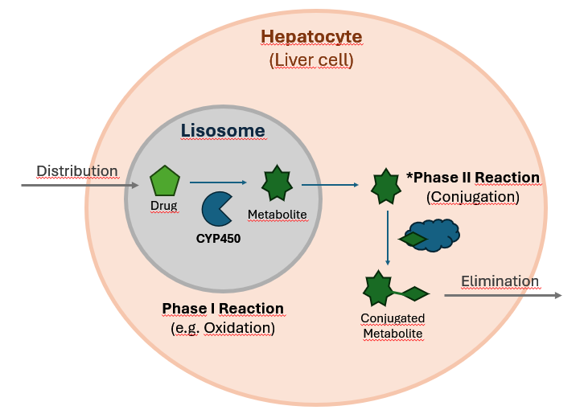
Figure 1 A simplified overview of hepatic drug metabolism. Phase I reactions introduce or reveal polar functional groups via processes such as oxidation, reduction, and hydrolysis. *The resulting Phase I metabolites may be directly excreted or can proceed to a subsequent conjugation step with hydrophilic molecules (Phase II reactions). Source: Original artwork by the author.
Because they reflect the full enzymatic and physiological context of the liver, primary hepatocytes are considered the gold standard for studying drug metabolism. They provide a near-complete representation of how a compound would behave in human systems, allowing for precise determination of metabolites, rates of clearance, and enzyme pathways involved. However, the value of hepatocytes comes with significant limitations: they are expensive, often costing hundreds of dollars per experiment, and they require specialized culture conditions and expertise. Their limited availability (due to donor dependence), relatively short lifespan, and low throughput make them unsuitable for screening large libraries of early-stage drug candidates. As a result, hepatocyte studies are typically reserved for promising molecules during late preclinical stages.
To address the need for faster and more cost-effective metabolism screening, liver microsomes have become a widely used alternative. Microsomes are subcellular fractions derived from the endoplasmic reticulum of hepatocytes, containing a concentrated pool of Phase I enzymes, particularly the CYP450 family. Although they lack the full cellular machinery required for Phase II conjugation reactions, microsomes are highly useful for early characterization of oxidative metabolism and enzyme-specific activity. Their high throughput and lower cost—often an order of magnitude cheaper than hepatocyte assays—make them particularly well suited for early drug discovery when many candidate molecules are being tested.
One important consideration in early drug metabolism studies is that Phase I reactions, which are largely mediated by CYP450 enzymes, tend to be more unpredictable and clinically significant than Phase II reactions. Phase I often introduces functional groups to a molecule, creating reactive intermediates or metabolites that can lead to drug–drug interactions or unexpected toxicity. In contrast, Phase II reactions, such as glucuronidation, typically involve conjugation with endogenous molecules, which generally renders compounds less active and more easily excreted, making these reactions less prone to harmful interactions. Since CYP450 enzymes play a dominant role in Phase I metabolism, understanding and predicting their involvement provides valuable insight into one of the most critical determinants of drug safety and efficacy.

In silico approaches
Beyond experimental systems, advances in computational power and the availability of molecular data have given rise to in silico technologies designed to predict drug metabolism. Rule-based expert systems, such as MetaSite and StarDrop (with its WhichP450™ model), attempt to forecast how molecules are processed by specific enzymes, including CYP450 isoforms. These tools offer rapid predictions and can screen large compound libraries at a scale far beyond what any in vitro system could achieve. However, their proprietary nature and high licensing costs, ranging from several thousand euros per project for MetaSite to annual subscriptions exceeding tens of thousands of euros for StarDrop, can make them less accessible, particularly for early-stage research teams or academic groups.
From a technological standpoint, these algorithmic solutions are based on a combination of mechanistic models and ML to simulate drug-enzyme interactions. StarDrop’s Semeta platform integrates enzyme-specific regioselectivity models, quantum mechanical simulations, and predictive heuristics to identify likely metabolic pathways across major Phase I and Phase II enzymes, including CYP450 isoforms [4]. MetaSite, on the other hand, leverages structure-based docking, flexible interaction fields, and structure–activity relationships (SARs) to model how xenobiotic compounds interact with enzyme active sites, ranking predicted poses through energy-based scoring functions [5]. While these approaches have proven accuracy and the advantage of incorporating detailed enzyme knowledge, they can also be computationally intensive, particularly when simulating multiple enzyme systems or large libraries of molecules.
Despite the proprietary nature of these platforms, the state of the art regarding in silico models relies heavily on ensemble modelling, a technique where multiple predictive models are combined to produce a more accurate and reliable outcome than any single model could achieve on its own. In the case of Semeta, for example, separate models such as WhichP450 and WhichEnzyme are integrated alongside regioselectivity predictors to collectively determine the most likely metabolic routes. This combined approach helps balance out the limitations of individual models by bringing together the strengths of different algorithms, leading to more reliable and accurate predictions.
Academic platforms such as CYPstrate [6], CYPReact [7], DeepP450 [8], and the metabolism modules of ADMETlab 3.0 [9] illustrate the consolidation of supervised learning for CYP450 isoform prediction. These systems typically cast metabolism as isoform-specific classification tasks, often decomposed into binary or multi-label problems, and rely on ensemble tree methods (e.g., Random Forest, gradient boosting), Support Vector Machines, or deep neural architectures operating on SMILES-derived descriptors. While differing in scale and implementation, they share a common design pattern: curated structural datasets, fixed molecular representations (fingerprints or sequence encodings), and independent models per endpoint, prioritizing statistical generalization over mechanistic enzyme simulation.

Molecular representations
Among the various chemical representations in computational chemistry, SMILES (Simplified Molecular Input Line Entry System) stands as the predominant format for encoding molecular structures. SMILES’ popularity stems from its computational efficiency and widespread support across cheminformatics tools, making it the standard input for most cheminformatics algorithms. However, SMILES is not without limitations. Its non-canonical nature means that multiple strings can represent the same molecule, complicating tasks that rely on unique identifiers. Challenges also arise when representing protonated species, compounds containing transition metals, or more complex molecular structures, where SMILES may lack precision and consistency.
To characterize molecular features for ML, chemical fingerprints are preferred over learned embeddings, particularly when datasets contain a relatively small number of compounds, usually in the thousands. Fingerprints such as MACCS keys, which provide a compact 166-bit vector, offer computational simplicity but often lack sufficient detail for predictive modelling. More informative are Morgan fingerprints [10], with adjustable lengths that capture substructural patterns. This work employs Morgan fingerprints of length 2048 bits rather than shorter alternatives like 512 or 1024, as the greater dimensionality better encodes chemical variability and subtle structural differences. Overall, fingerprints continue to dominate as the preferred molecular representation due to their efficiency and interpretability, although emerging embedding techniques have begun to attract attention for their potential to capture richer structural information.
Early work on learned molecular representations gave rise to Mol2Vec [11], proposed in 2018, which adapts natural language processing techniques to chemistry by treating molecular substructures as “words” and learning continuous vector representations using a Word2Vec-style framework. Mol2Vec demonstrated that unsupervised embeddings derived from molecular fragments could capture chemical similarity and improve performance over traditional fingerprints in some predictive tasks. More recently, advances in deep learning have led to transformer-based language models for chemistry, such as ChemBERTa (2020) [12], which learn contextualized embeddings directly from SMILES strings and offer substantially higher representational capacity. In parallel, large-scale industrial efforts have produced highly optimized pretrained models such as MolE (2023) [13], which leverage massive chemical corpora to generate general-purpose molecular embeddings. Together, these approaches represent the current state of the art in molecular representation learning, complementing classical fingerprints.
Despite the methodological advances described above, virtually all modern molecular ML pipelines (fingerprint-based or embedding-based) take SMILES as their starting point. Even transformer models and large pretrained encoders operate directly on SMILES strings. The field has implicitly adopted SMILES syntax as the de facto language of chemical structure. By contrast, the IUPAC International Chemical Identifier (InChI) was specifically designed to provide a canonical and standardized encoding of molecular connectivity and stereochemistry, yet it remains comparatively underexplored in representation learning frameworks. This imbalance raises a question: does SMILES dominate because it is representationally superior, or merely because it arrived first and gathered momentum? While SMILES offers flexibility and broad software support, its non-unique nature requires canonicalization, as multiple valid strings may correspond to the same molecule. InChI, in principle, reduces such ambiguity through deterministic encoding, but its layered and highly structured format may present different modelling challenges. The limited adoption of InChI in ML is therefore not a settled conclusion but an open design choice. As a complementary line of inquiry, this thesis explores whether an InChI-native encoder can learn representations that complement or challenge those derived from SMILES.

OBJECTIVES
Main objective:
- To develop and evaluate ML models capable of predicting the metabolism of drug-like molecules by classifying them according to the CYP450 isoenzymes most likely to metabolize them, using publicly available molecular data and annotations.
Secondary objectives:
- Apply Extract, Transform, Load techniques to collect, sanitize, and preprocess molecular structure datasets and metabolic annotations from public sources such as ChEMBL and DrugBank.
- Conduct exploratory data analysis (EDA) to characterize label distributions, multi-label co-occurrence patterns, and data quality issues, and to derive clear implications for modelling strategies and validation protocols.
- Establish an internal benchmark comparing multiple molecular representations, including Morgan fingerprints, MolE embeddings, and ChemBERTa embeddings, under consistent validation conditions to assess their relative effectiveness for CYP450 prediction.
- Pretrain a custom transformer-based language model on a large corpus of InChI strings as a complementary line of inquiry and evaluate whether the resulting embeddings offer distinct or complementary predictive signal compared to SMILES-based representations.
- Assess model performance using appropriate multi-label metrics, validate predictions against known experimental data, and discuss how the findings may inform representation choices in early drug discovery pipelines.

METHODOLOGY

Reproducibility & tooling
The source code and coursework developed for this project has been uploaded and maintained in a public GitHub repository, ensuring proper version control and accessibility.
Large language models were used exclusively as auxiliary tools for improving documentation clarity and code readability (e.g. function doc strings). This approach ensured that the source code remained both accessible and transparent for future review and development. All modelling decisions, preprocessing strategies, and scientific reasoning were independently defined and validated by the author.
All computational work was performed on local hardware. No cloud computing resources or external services were used for model training or evaluation.

Data Acquisition & Management
For data acquisition, an account in go.drugbank.com was created and an academic research application was submitted to gain access to their high-quality metabolism-related db. Kaggle was used to obtain 1.5 million compound SMILES.
For data management, relational tables were created and handled using the Python library pandas, as the datasets involved are relatively small in size. This is particularly the case for drug-related data, where the number of compounds, especially those tested for metabolism, is limited and does not require large-scale or distributed db solutions.
To address missing structural data such as SMILES and InChI identifiers within the original DrugBank compound dataset, a ChemSpiPy account was created in order to use its API to query for the missing InChI/SMILES. To ensure efficient use of the API and avoid exceeding request limits, retrieved results were cached locally after the first successful query. This prevented redundant calls for the same compound reducing network overhead on subsequent executions of the pipeline.

Molecular Representation Strategy
For the broader cheminformatics workflow, RDKit [14] was further utilized to generate molecular fingerprints. Specifically, the Morgan fingerprint algorithm was applied through RDKit’s FingerprintGenerator API with radius = 3 to convert SMILES-encoded structures into fixed-length numerical vectors. This type of fingerprint is commonly known as an Extended-Connectivity Fingerprint or ECFP6. The number '6' refers to the size of the molecular features it captures; a radius of 3 means it examines an area spanning 6 bonds across (2 x radius), hence the name ECFP6.
A radius of 3 was selected to balance local and extended structural context. This value is widely used in QSAR studies and bioactivity benchmarks because it empirically captures pharmacophoric environments well without causing excessive feature sparsity [15].
Formally, the fingerprint transformation can be expressed as:
$$φ:M⟼{\left\{0,1\right\}}^{d}$$
where each coordinate encodes the presence of a hashed subgraph of radius r.
Although ECFP6 fingerprints are commonly implemented in binary form, they can alternatively be represented in a count-based format, where each feature is encoded as the number of times the corresponding substructure appears in the molecule rather than as a simple presence/absence indicator. This formulation preserves information about substructure multiplicity and therefore provides a more expressive representation, introducing greater variability across molecular vectors. In the context of metabolic prediction, such quantitative information may be particularly relevant, as the frequency of specific functional groups or structural motifs could influence the likelihood of enzymatic interaction. For this reason, a count-based ECFP6 representation was adopted in this work using RDKit’s implementation:
GetMorganGenerator(radius = 3, fpSize = 2048).GetCountFingerprint()
Beyond traditional handcrafted fingerprints, recent advances in molecular ML have introduced embedding-based representations, in which molecules are mapped to continuous latent vectors learned from large chemical corpora. Whereas Morgan fingerprints deterministically encode predefined substructural patterns through hashing, learned embeddings aim to capture higher-order chemical relationships, potentially reflecting subtle electronic, steric, or contextual dependencies that are not explicitly enumerated by fragment-based descriptors [16].
However, the effectiveness of these embeddings depends heavily on data scale. In small to medium-sized datasets, such as the DrugBank-derived corpus used in this study, training or fine-tuning models carries substantial risk of overfitting and reduced generalization. For this reason, two pretrained embedding models (MolE and ChemBERTa) were employed in this work as frozen feature extractors, enabling an evaluation of their representational power while reducing overfitting risk. This framework allows for a structured assessment of whether continuous learned representations offer additional predictive signal over established deterministic descriptors in the context of CYP450 metabolism prediction.
In contrast to fixed-length fingerprint vectors, embedding methods operate on sequential molecular representations:
$$M ⟼\left(e\left(t_{1}\right), e\left(t_{2}\right), …, e\left(t_{n}\right)\right) ϵR^{n×d}$$
where t_{i} are tokens in the SMILES and e(⋅) is a learned embedding function. A downstream sequence model f_{θ}​ compresses this into a molecular representation:
$$z= f_{θ}\left(e\left(t_{1}\right), e\left(t_{2}\right), … , e\left(t_{n}\right)\right)ϵ R^{k}$$
Thus, in contrast to fingerprints that are a hand-crafted projection into a discrete feature space, embeddings are a learned mapping into a continuous latent space. In high-data regimes, the continuous space should approximate chemical similarity more flexibly, whereas in low-data regimes, the discrete handcrafted features often outperform.
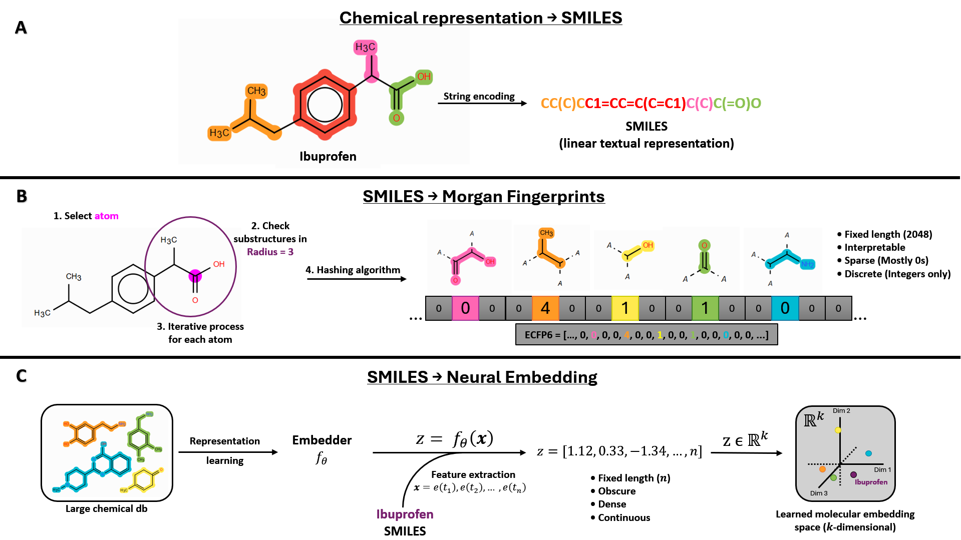
Figure 2 Schema of molecular representation pipelines. Source: Original artwork by the author.
(A) Example molecule (ibuprofen) and its SMILES encoding.
(B) Illustration of ECFP6 generation, where circular substructures (radius = 3) are enumerated and hashed into a fixed-length vector. This results in a sparse, discrete representation capturing predefined molecular fragments.
(C) Learned molecular embedding approach. A molecular encoder $f_{θ}$ is trained on a large chemical database through a general representation learning process. Given a new molecule (e.g., ibuprofen), its SMILES string is tokenized and converted into a sequence of embeddings $x=(e(t_{1}),e(t_{2}),…,e(t_{n}))$, which is then processed by the encoder to produce a continuous vector $z=f_{θ}(x)∈R^{k}$. This vector defines the position of the molecule within a learned $k$-dimensional latent space, where proximity between points reflects similarity in the encoded molecular features.
Binary fingerprints, and to a lesser extent count-based variants, represent molecules as collections of predefined substructures. While this strategy has proven highly effective in many QSAR applications, it ultimately reduces chemical space to a catalogue of fragments, potentially overlooking more subtle steric, electronic, or conformational effects that may influence enzymatic recognition. In the context of CYP450 metabolism, where substrate specificity depends not only on the presence of functional groups but also on their accessibility and surrounding environment, such simplification may limit the expressiveness of purely fragment-based descriptors.
Learned embeddings attempt to address this limitation by mapping molecules into dense continuous vector spaces, where structural similarity is inferred from patterns learned across large chemical corpora rather than from explicit substructure overlap. In principle, this allows chemically related molecules to occupy nearby regions in embedding space even when they do not share identical hashed fragments. However, the advantages of this approach are closely tied to data scale and model capacity; without sufficient training data, high-dimensional embeddings may fail to generalize and can underperform simpler, handcrafted representations.
Within embedding methodologies, an important distinction arises between static and contextualized representations. Static embeddings assign a fixed vector to each molecular fragment or token, meaning that a given substructure is represented identically regardless of its chemical environment. Among the available approaches, two representative models were selected, MolE and ChemBERTa. MolE (version 1), when used as frozen encoders, generate a single holistic embedding for the entire molecule based on patterns learned during large-scale pretraining. In contrast, transformer-based models such as ChemBERTa (ChemBERTa-zinc-base-v1) produce contextualized token embeddings: each atom or symbol in a SMILES string is encoded in relation to the full molecular sequence, allowing its representation to vary depending on neighbouring atoms and overall structure. This distinction is particularly relevant for metabolic prediction, as enzymatic activity is not determined solely by the presence of reactive groups but also by their steric accessibility, electronic modulation, and broader molecular context.
To ensure a fair comparison between molecular representations, all downstream models were evaluated under an identical benchmark framework using frozen multilabel-stratified train/test partitions and cross-validation (CV) folds. Three supervised learning approaches were considered: Logistic Regression (LR) as a linear baseline, Random Forest (RF) as a classical ensemble-tree method, and Extreme Gradient Boosting (XGBoost) as the primary gradient-boosting framework. In addition, a majority-class baseline predictor was included to establish a minimal reference level of performance. For every representation-model combination, hyperparameters were optimized via grid search exclusively on the training data, while prediction thresholds (τ) were selected independently for each CYP isoform during CV. Final performance was assessed on a held-out test set using the same evaluation metrics throughout the study, namely macro-averaged Matthews Correlation Coefficient (MCC) as the principal metric, together with Micro-F1 and Hamming Loss as complementary measures of multilabel prediction quality.
By evaluating both MolE and ChemBERTa alongside Morgan fingerprints, this work attempts to assess whether increasingly expressive representation strategies translate into improved predictive performance for CYP450 metabolism.

Pre-training an InChI-Based Molecular Language Model for Feature Extraction (Complementary Experiment)
To complement the SMILES-based embeddings from MolE and ChemBERTa, a transformer-based masked language model (MLM) was pre-trained on 1.5 million InChI strings. This InChI-native encoder allows a controlled comparison of whether canonical, non-SMILES representations provide distinct or complementary signal for CYP450 prediction.

Motivation and Experimental Rationale
Most contemporary molecular language models, including MolE and ChemBERTa, operate exclusively on SMILES strings as their textual representation of chemical structure. As previously discussed, while SMILES is practical and widely adopted, it is not a canonical encoding by default and can admit multiple valid strings for the same molecule. In contrast, InChI provides a standardized, hierarchical, and deterministic representation designed to uniquely describe molecular connectivity and, most importantly, stereochemistry.
This experiment was therefore conceived as a complementary and tightly scoped study to explore whether a transformer-based language model pretrained directly on InChI strings could learn meaningful structural representations that are usable for downstream CYP450 prediction. Given the relatively small size of the curated DrugBank dataset (~1.3k compounds), it is unlikely that a self-trained embedder would systematically outperform established fingerprints or large-scale pretrained models. However, evaluating an InChI-native encoder provides a principled way to examine whether non-SMILES textual encodings can capture alternative structural signals, such as the spatial arrangement of functional groups and stereochemical configurations, that are essential for enzyme-substrate interactions
Accordingly, this component is positioned as an exploratory extension that complements the primary internal benchmark, while contributing to the broader discussion on representation choice (SMILES vs. InChI) in cheminformatics-based learning systems.

Model Architecture & Training Setup
A transformer-based MLM was trained from scratch on InChI strings following a RoBERTa-style architecture [17], [18]. The training was purely self-supervised reconstructing randomly masked tokens within each InChI sequence. No metabolic annotations or downstream labels were used at this stage. This ensures that the learned representations encode general structural regularities of chemical compounds rather than task-specific information related to CYP450 metabolism.
Prior to model training, a custom tokenizer was built using a Byte-Pair Encoding (BPE) strategy [19]. A BPE approach was selected to avoid manually defining chemistry-specific token rules and to allow the tokenizer to automatically learn recurring structural patterns within InChI strings (e.g., connectivity blocks, InChI-specific syntax, layer separators) [20]. Given the relatively constrained alphabet and syntax of InChI representations, the vocabulary size was fixed at 2,000 tokens, which felt like a safe choice without extending it unnecessarily. A minimum token frequency of 2 was imposed to filter out spurious fragments generated by rare character combinations.
Sequences were truncated to a maximum length of 512 tokens to ensure stable training and compatibility with GPU memory constraints. Dynamic padding was enabled at batch level to avoid excessive memory usage while maintaining computational efficiency. These decisions were primarily pragmatic, as early runs revealed instability and memory limitations when allowing unbounded sequence lengths. This saved memory and made training feasible.
The transformer encoder was configured as a compact yet expressive model, with 6 hidden layers, a hidden size of 384, and 6 attention heads. This configuration provides sufficient representational capacity for learning structural dependencies in InChI sequences while remaining computationally tractable under the author’s limited hardware resources (4GB VRAM). The masked language modelling probability was set to 15%, following standard practice in transformer pretraining [17]. Training was conducted for three epochs using mixed precision (fp16) to improve efficiency, with gradient accumulation to achieve a stable effective batch size. A cosine learning rate scheduler and weight decay were applied to stabilize optimization [21].
The architectural scale and number of training epochs were not selected to maximize language modelling performance, but to obtain a structurally meaningful encoder within the practical time and hardware constraints of the project. Consequently, this model should be interpreted as a lightweight, domain-specific pretraining experiment rather than a large-scale foundation model comparable to industrial pretrained systems.

Positioning & Limitations
The architectural configuration of the InChI language model was primarily determined by computational constraints. The model was intentionally designed as a compact transformer (6 layers, hidden size 384, 6 attention heads) to remain computationally feasible under limited hardware resources. In contrast, large pretrained models such as ChemBERTa typically employ substantially larger hidden dimensions, deeper stacks, and are trained on tens of millions of molecules [12]. A direct performance comparison between this lightweight, domain-specific pretraining experiment and large-scale industrial or academic foundation models would therefore be inherently unfair. The present model was not optimized through extensive hyperparameter exploration nor scaled following established transformer scaling practices; rather, it was configured to obtain a stable and interpretable encoder within the time and resource boundaries of a master’s thesis project.
To accommodate GPU memory limitations, gradient accumulation was employed to simulate a larger effective batch size while maintaining small per-device batches. This is a standard technique in deep learning practice [22]. This approach reduces the variance of gradient estimates relative to very small batches, at the cost of less frequent parameter updates. Similarly, mixed-precision training (16-bit floating point) was enabled to reduce memory footprint and accelerate computation [23]. Although widely adopted in transformer training, reduced-precision arithmetic introduces minor numerical approximations compared to full 32-bit computation.
Tokenizer and sequence-length decisions also introduce assumptions. All sequences were truncated to a maximum of 512 tokens, and dynamic batch padding was applied to optimize memory usage. This implies that very long InChI strings, potentially those corresponding to large molecules or compounds with complex stereochemical layers, lose information beyond position 512. Implicitly, the model assumes that the initial portion of the InChI string contains sufficient structural information to capture features relevant for CYP450 metabolism, although this may have theoretical caveats. For most drug-like small molecules, this is a reasonable working assumption, as their InChI representations rarely approach extreme lengths. Nevertheless, this truncation constitutes a structural limitation of the representation and may disproportionately affect unusually large or complex compounds.
More broadly, this experiment does not attempt to claim architectural optimality. Decisions regarding vocabulary size, layer depth, hidden dimensionality, masking strategy, and scheduler configuration were guided by established transformer practices and empirical stability, but not by exhaustive ablation studies. Exploring alternative scaling regimes, tokenizer granularities, or architectural variants would require substantially larger computational resources. Consequently, the InChI encoder should be interpreted as an exploratory representation study rather than a definitive benchmark against state-of-the-art pretrained molecular language models.

Predictive Modelling Framework

Problem definition: Multi-label classification
Predictions of CYP450 metabolism are considered a multi-label classification problem, in which each molecule may be associated with zero, one, or multiple enzymes simultaneously. Unlike traditional single-label classification, where each instance is assigned to exactly one category, multi-label settings require the model to learn non-mutually exclusive relationships between input features and a set of target labels, CYP450 enzymes in our case.
Formally, given a dataset of molecular $X ∈ R^{n × d}$, the objective is to learn a mapping to a label matrix $Y ∈ {\left\{0, 1\right\}}^{n × k}$ where k denotes the number of CYP isoforms considered, XX in our case after removing low frequency isoforms. Each row of Y encodes a binary vector indicating the presence or absence of metabolism by each enzyme. From a ML perspective, a key challenge arises: label imbalance.
In our dataset, the distribution of CYP isoforms is highly skewed. A small number of enzymes, such as CYP3A4, dominate the dataset, while others appear much less frequently. This long-tail distribution leads to a scenario where standard learners tend to prioritise performance on frequent labels at the expense of rare but biologically important ones. As a result, naïve optimization strategies can produce models that at first glance appear competitive while failing to capture meaningful signals for infrequent enzymes. This issue is well-documented in multi-label learning literature, where imbalance has been shown to significantly degrade classifier performance, particularly for minority labels. [24]
From a modelling perspective, the task can be interpreted as learning a set of decision boundaries in a high-dimensional space, where each boundary corresponds to the likelihood that a molecule is metabolized by a given enzyme. In this work, we train a separate binary classifier for each CYP enzyme, treating each as its own binary prediction problem. This strategy is widely used in cheminformatics due to its simplicity, scalability, and robustness, particularly when dataset size is limited. [25] Although this approach may ignore some complex phenomena, like inter-label dependencies, it allows for clear interpretability and avoids compounding errors across labels.
In the context of drug discovery, the ideal model is one that considers the associate cost of bad predictions, especially considering the disproportionate cost of a false negative (FN) compared to a false positive (FP). Unlike many classification tasks where precision and recall are treated symmetrically, due to this imbalance, CYP prediction operates under asymmetric costs. A FN can have severe downstream consequences, including toxicity, drug–drug interactions, or late-stage clinical failure. Conversely, a FP, although costly due to additional experimental validation, does not inherently compromise safety or put in jeopardy the products development. This asymmetry implies that the model should favour sensitivity to true interactions even at the expense of a moderate increase in false positives, all while keeping an equilibrium between correct and incorrect predictions that can provide value to the investigators.

Algorithms evaluated
To evaluate the predictive value of the different molecular representations, several ML algorithms with progressively increasing modelling capacity were selected and assessed under the same validation framework. Rather than focusing on a single architecture, this benchmark was designed to compare how different classes of predictive models interact with fingerprint-based and embedding-based representations in the context of CYP450 metabolism prediction. The evaluated approaches range from a naïve majority baseline to linear and nonlinear ensemble methods, allowing both representation quality and model complexity to be analysed in a controlled and reproducible manner.

Majority Predictor
In the ‘majority_predictor.py’ file, a naïve majority-class baseline predictor was implemented to establish a minimal reference point for the benchmark. The model followed the same binary relevance formulation used throughout the study, treating each CYP isoform as an independent binary classification problem.
For every CYP, the predictor assigned to all molecules the most frequent class observed in the training set. Due to the class imbalance present in the dataset, this resulted in constant negative predictions for most isoforms, while CYP3A4 was consistently predicted as positive. No molecular descriptors or embeddings were used, as the baseline relied exclusively on class prevalence.

Although intentionally simplistic, this approach provides methodological context for interpreting the subsequent models. In highly imbalanced multilabel settings, trivial predictors may appear competitive under some metrics despite lacking any real discriminatory capability. Including this baseline therefore allows the performance of the supervised models to be evaluated against a clearly defined lower bound under the same train/test partitions and evaluation framework.

Logistic Regression
LR was selected as the primary linear baseline for the benchmark due to its widespread use in cheminformatics and its strong performance on sparse molecular descriptors, such as ECFP6. Unlike the majority predictor, LR incorporates molecular features directly into the decision process by learning a weighted linear combination of input variables associated with the probability of a molecule belonging to a given class.
For each CYP isoform, the model estimated the probability of metabolism through the logistic function:
$$P(y=1|x)= \frac{1}{1+ e^{-(ω^{T}x+b)}}$$
where $x$ is the molecular feature vector (e.g., ECFP6 counts), $ω$ the learned feature weights, and $b$ the intercept term. The expression $ω^{T}x$ denotes the dot product $\sum_{j}{ω_{j}x_{j}}$ , which combines the features linearly. The logistic function then maps the linear score $z= ω^{T}x+b$ to a probability between 0 and 1, producing an S‑shaped curve (Figure 3). A score of zero gives a probability of 0.5 while large positive scores approach 1, and large negative scores approach 0.
The resulting probability was later converted into a binary prediction through a decision threshold (τ): the molecule is predicted to be metabolised if $P(y=1|x) ≥ τ$. Instead of using a fixed τ (e.g., 0.5), we optimise τ independently for each CYP during CV to maximise the validation MCC.
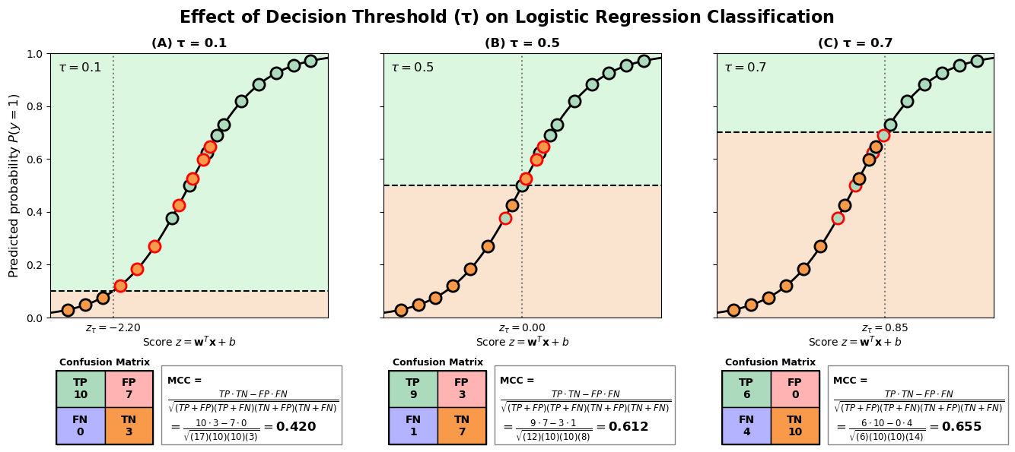
Figure 3 Effect of τ on LR classification. Source: Original artwork by the author.
The same fitted LR model is shown in all panels. Green and orange points represent TP and TN molecules, respectively; red outlines indicate misclassified compounds. The shaded regions denote the predicted positive and negative decision spaces for each τ. Confusion matrices and the corresponding MCC calculation are shown below each panel. In this illustrative example, τ=0.7 would be chosen as the preferred τ as it returns the highest MCC value. Note that optimizing MCC may increase the number of FN, a potentially undesirable outcome in drug discovery where missing a true metabolic interaction can have important safety implications.
LR has historically shown competitive performance in QSAR and molecular property prediction tasks involving fingerprint representations, particularly when dataset sizes are moderate and descriptor spaces are highly sparse and high-dimensional. [26] Morgan fingerprints are especially well suited for this type of model because each bit or count corresponds to the presence of specific local substructures, allowing the classifier to assign interpretable positive or negative weights to chemically relevant fragments. [15] Previous benchmarking studies in cheminformatics have consistently reported Logistic Regression as a robust baseline for fingerprint-based molecular classification tasks, often remaining competitive against more complex methods on medium-sized datasets. [27] Nevertheless, in some cases LR has been observed to be more prone to overfitting than some alternative ML approaches, particularly when applied to high-dimensional molecular descriptors. [26] Despite this limitation, the method remained a competitive baseline across multiple benchmark datasets and was therefore included in the present study as a representative linear classifier.
The implementation followed the same binary relevance strategy used throughout the study, training one independent classifier per CYP isoform under identical train/test partitions and CV folds. This strategy simplifies the modelling process while allowing each CYP to learn its own decision boundary and class distribution. To address class imbalance, all models used the parameter class_weight="balanced", which automatically adjusts class contributions inversely proportional to their observed frequencies in the training data.
A controlled hyperparameter grid search was then performed to identify suitable model configurations while maintaining a fair comparison with the remaining algorithms evaluated in this work. The hyperparameters explored for Logistic Regression are summarized in Table 1.
Table 1 Hyperparameter search space evaluated for Logistic Regression
Hyperparameter | Values explored | Description
C | 0.01, 0.1, 1.0, 10.0 | Inverse regularization strength. Smaller values impose stronger regularization, reducing coefficient magnitude and helping prevent overfitting.
penalty | L1 (Lasso), L2 (Ridge) | Type of regularization applied to model coefficients.
solver | liblinear, saga | Numerical optimization algorithm used to estimate model parameters.
max_iter | 5000 | Maximum number of optimization iterations allowed before stopping.

The explored values were selected to cover a moderate range of regularization strengths commonly used in cheminformatics classification tasks without introducing excessively large search spaces that could favour this model unfairly relative to the other benchmarked approaches. In particular, very large C values were avoided because they substantially reduce regularization and may lead to data overfitting.
Two regularization schemes were evaluated. L1 (Lasso) regularization promotes sparsity by driving less informative coefficients toward zero, effectively performing an implicit feature selection step. [28] This behaviour is particularly relevant for fingerprint representations, where thousands of sparse features may be present simultaneously. In contrast, L2 (Ridge) regularization distributes penalties more smoothly across coefficients, generally producing more stable solutions when many correlated features coexist. [29]
Regarding solver selection, preliminary experiments showed that the lbfgs solver frequently failed to converge for several CYP-specific models, even after substantially increasing the maximum number of iterations up to 10,000. In practical terms, convergence refers to the optimization process reaching a stable solution where further iterations no longer meaningfully improve the model parameters. Failure to converge indicates that the algorithm was unable to reliably identify such a stable optimum under the imposed iteration limits. Additionally, lbfgs does not support L1 regularization, which further limited its suitability for the present benchmark. Consequently, the liblinear and saga solvers were selected, as both are compatible with sparse high-dimensional data and support the regularization schemes evaluated in this study.

Random Forest
RF was selected as the principal classical ensemble-learning baseline in this study. Unlike LR, which learns a single linear decision boundary, RF combines the predictions of many decision trees, allowing it to capture complex and potentially nonlinear relationships between molecular features and metabolic activity. This characteristic has made RF one of the most widely used algorithms in QSAR modelling and molecular property prediction, where structure-activity relationships are often driven by interactions between multiple molecular descriptors rather than by individual features in isolation.
The algorithm constructs multiple decision trees from randomly sampled subsets of both molecules and features. Each tree independently learns a series of decision rules that partition the chemical space according to the molecular representation provided. For classification tasks, the final prediction is obtained by aggregating the predictions of all trees in the ensemble, this is, the fraction of trees in the ensemble that vote for the positive class. This combination of bootstrap sampling and feature randomization reduces variance and improves generalisation. [30]
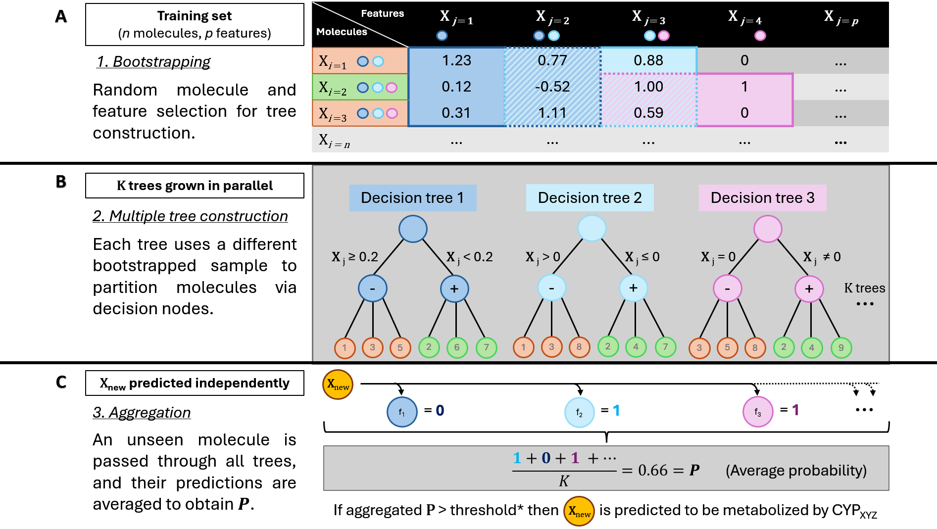
Figure 4 Schematic representation of the RF classification process. *Threshold optimised during CV per CYP (τ). Source: Original artwork by the author.
(A) Starting from the training dataset composed of n molecules and p molecular features, bootstrap samples are generated by randomly selecting molecules with replacement. During tree construction, random subsets of features are considered at each split, increasing diversity among trees. Coloured circles illustrate repeated sampling of molecules into different bootstrap datasets.
(B) Multiple decision trees are grown independently from the bootstrapped datasets. Each tree partitions the molecular feature space through a series of decision nodes based on different subsets of molecular descriptors, producing individual predictions for the target CYP isoform. Only three representative trees are shown for clarity, although the final model consists of a larger ensemble (K trees).
(C) For an unseen molecule X_{new}, predictions from all trees are aggregated to obtain a final class probability P. The probability corresponds to the proportion of trees predicting the positive class and is subsequently compared against a predefined τ to determine whether the molecule is predicted to be metabolized by the CYP isoform under consideration.
RF has been extensively applied in cheminformatics and is frequently reported as a strong baseline for molecular classification tasks due to its ability to model nonlinear relationships without requiring extensive feature engineering or feature scaling. This property makes it particularly suitable for fingerprint-based representations, where interactions between different structural fragments may contribute jointly to metabolic behaviour. [31] Furthermore, RF can naturally handle both sparse count-based descriptors and dense embedding vectors, making it well suited for the comparative benchmark performed in this work. [26]
As in the LR implementation, a binary relevance strategy was adopted. A separate RF classifier was trained for each CYP isoform, allowing each enzyme to learn its own class distribution and decision boundaries independently. All models were trained and evaluated using the same fixed train/test partition and the same CV folds employed throughout the benchmark. To account for class imbalance, the parameter class_weight="balanced" was applied to all models, increasing the influence of minority-class observations during tree construction.
Model selection was performed through an exhaustive grid search using the training set only. For each hyperparameter combination, a RF model was trained for every CYP isoform and evaluated across the predefined CV folds. As with the other algorithms, τ was optimized independently for each CYP by maximizing the average validation MCC over the set of candidate τ. The best global hyperparameter configuration was then selected according to the highest average Macro MCC across all CYPs, with ties resolved in favour of the configuration showing lower variance between isoforms. This procedure ensured that model selection remained consistent with the evaluation framework used throughout the study.
The explored hyperparameters are summarized in Table 2.
Table 2 Hyperparameter search space evaluated for RF
Hyperparameter | Values explored | Description
n_estimators | 200, 300 | Number of decision trees in the ensemble.
max_depth | 12, 20 | Maximum depth allowed for each decision tree.
min_samples_split | 3, 5 | Minimum number of samples required to split an internal node.
max_features | sqrt, log2 | Number of features considered when searching for the best split at each node.

The selected search space was designed to balance model flexibility and computational cost while reducing the risk of excessive overfitting. The number of trees was limited to values commonly reported in molecular property prediction studies, where performance gains tend to plateau beyond a few hundred trees while computational requirements continue to increase. Tree depth was restricted to moderate values rather than allowing unrestricted growth, as very deep trees can memorize training observations and are particularly susceptible to overfitting in smaller datasets and less frequent CYP classes. Similarly, the min_samples_split parameter was included to prevent overly specific decision rules from being generated from only a handful of training examples.
The max_features parameter controls the degree of randomness introduced during tree construction. Evaluating both the square-root and logarithmic strategies allowed the benchmark to compare two commonly used approaches for reducing correlation between trees while maintaining sufficient diversity within the ensemble. Together, these hyperparameters govern the balance between model complexity, robustness, and generalization ability, making them the most influential variables in RF performance for the present application.

XGBoost
XGBoost was selected as the primary ML algorithm for this benchmark due to its strong performance on structured data and its widespread adoption in cheminformatics and bioinformatics applications. [26], [31] Unlike RF, which constructs multiple decision trees independently and combines their predictions through bagging, XGBoost builds trees sequentially. Each new tree is trained to correct the residual errors made by the existing ensemble, progressively improving the overall predictive performance. This sequential learning strategy allows the model to capture complex nonlinear relationships while maintaining a relatively compact architecture. [32]
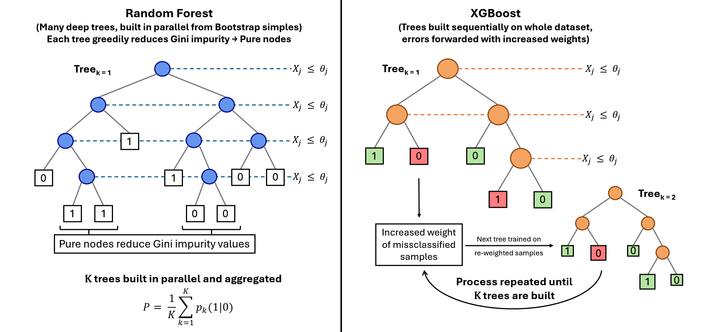
Figure 5 Comparison of the learning procedures of RF and XGBoost.
Random Forest (left) builds multiple deep decision trees in parallel from bootstrap samples, greedily selecting splits ($X_{j} ≤ θ_{j}$) that reduce Gini impurity until pure terminal nodes are reached. Predictions are aggregated by averaging the outputs of the K trees. XGBoost (right) sequentially constructs shallower trees using the full training set, where each new tree is trained to correct the errors of the previous ensemble by increasing the influence of misclassified samples. Source: Original artwork by the author.
From a mathematical perspective, XGBoost minimizes an objective function composed of a prediction loss term and a regularization component:
$$L= \sum_{i}{l\left(y_{i}, {\hat{y}}_{i}\right)+ }\sum_{k}{Ω\left(f_{k}\right)}$$
where $l$ represents the logistic loss used for binary classification, and $Ω\left(f_{k}\right)$ penalizes the complexity of each decision tree by accounting for number of leaves in the tree and its weights. This regularization mechanism helps to reduce overfitting by penalizing non-efficient complexity while retaining the ability to learn complex useful decision boundaries. [32]
Like RF, XGBoost can naturally process sparse count-based molecular descriptors such as Morgan fingerprints without requiring feature scaling or normalization. The algorithm can also be applied directly to dense embedding vectors like those generated by ChemBERTa, MolE or the author-made InChI encoder. Since tree-based methods partition the feature space through threshold-based decisions rather than distance calculations, they are generally less sensitive to differences in feature scale than many linear or distance-based methods. This makes XGBoost particularly suitable for a comparable benchmark involving different molecular representations.
As before, a binary relevance framework was adopted, training one independent XGBoost classifier for each CYP isoform, maintaining therefore a consistent modelling strategy across all evaluated algorithms. The same frozen train/test partition and the same CV folds were used throughout the benchmark to ensure comparability of results.
To address class imbalance, the parameter scale_pos_weight was computed independently for each CYP using the ratio between negative and positive examples present in the training set:
$$scale_pos_weight=\frac{N_{positive}}{N_{negative}}$$
This weighting scheme increases the contribution of minority-class observations during training without requiring any modification to the underlying data distribution.
Model selection was performed through a grid search procedure comparable to those used for the other algorithms, over a restricted set of hyperparameters chosen to balance model flexibility and generalization. The explored search space is summarized in Table 3.
Table 3 Hyperparameter search space evaluated for XGBoost
Hyperparameter | Values explored | Description
learning_rate | 0.05, 0.10, 0.20 | Shrinks the contribution of each tree added to the ensemble. Lower values generally improve generalization but require more boosting rounds.
max_depth | 6, 9 | Maximum depth of individual trees. Controls model complexity and the order of feature interactions that can be learned.
n_estimators | 100, 200, 300 | Number of boosting iterations (trees) in the ensemble.
scale_pos_weight | Calculated per CYP | Ratio of negative to positive training samples used to address class imbalance.

The selected ranges were intentionally conservative given the relatively limited size of the dataset. Very deep trees can memorize training examples and lead to unstable models, particularly for the less frequent CYP isoforms. For this reason, tree depth was restricted to a maximum of nine levels. Similarly, learning rates below 0.05 were not explored because they typically require substantially larger numbers of trees to achieve comparable performance, increasing both computational cost and the risk of fitting noise in small datasets. The chosen search space therefore reflects a compromise between model expressiveness and robustness.
As with the LR and RF implementations, hyperparameter selection was integrated with τ optimization. For each CYP and each hyperparameter combination, τ was optimized during CV by maximizing the average validation MCC. Once the optimal τ had been identified for every CYP, the average Macro MCC across all isoforms was used to select the best global hyperparameter configuration.
Following model selection, a final XGBoost classifier was retrained for each CYP using the complete training set and the selected hyperparameters. The corresponding optimal τ were retained and subsequently applied to the independent test set to obtain the final predictions and evaluation metrics. This procedure ensured that all model selection decisions remained confined to the training data, preventing information leakage from the test set.
Compared with RF, XGBoost is expected to benefit from its sequential error-correction mechanism and explicit regularization framework, which can often achieve similar or superior predictive performance using fewer trees. The ability to iteratively focus on difficult training examples may be particularly advantageous when modelling subtle structure-metabolism relationships that are not captured by individual trees alone. Nevertheless, boosting methods are also known to be more sensitive to hyperparameter selection and can overfit small datasets if model complexity is not appropriately constrained. The restricted search space and CV strategy adopted in this work were therefore intended to balance predictive performance with generalization ability.
All models were implemented using the XGBoost Python library and trained with n_jobs=1 to ensure deterministic and fully reproducible execution. Furthermore, the same train/test partitions, CV folds, τ optimization procedure, and evaluation metrics were used across all molecular representations and learning algorithms, ensuring that performance differences could be attributed to the representation and modelling choices rather than to variations in the experimental setup.

Model evaluation
A rigorous evaluation framework is essential for comparing molecular representations and for diagnosing model behaviour across CYP isoforms with widely different frequencies. Given the multi-label nature of the task and the severe imbalance between common and rare enzymes, standard classification metrics such as accuracy or per-class precision are insufficient. This insufficiency arises from a crucial practical consideration in drug discovery. In early-stage development, the cost of a false negative, this is, failing to predict that a compound interacts with a CYP enzyme when it does, is substantially higher than that of a false positive. A missed interaction can allow a problematic compound to advance through costly development, potentially leading to clinical trial failures due to unexpected toxicity or dangerous drug-drug interactions, or even post-market withdrawal. [2] The pharmaceutical industry has long recognised this challenge, with conventional prediction methods being wrong approximately one third of the time, resulting in millions of dollars and years of effort going to waste. [33] Consequently, accuracy would be dangerously misleading in this domain. A predictor that always returns negative would achieve high accuracy on rare CYPs simply because positive cases are so few, yet such a predictor would be useless in practice. For these reasons, a suite of more complete and appropriate metrics was selected to evaluate model performance and enable meaningful comparability across representations.

Primary Metric: Mean Matthews Correlation Coefficient (Macro MCC)
The MCC measures the quality of binary classifications by taking into account all four entries of the confusion matrix: true positives (TP), true negatives (TN), FP and FN. For a single CYP isoform, MCC is defined as
​$MCC= \frac{TP × TN - FP × FN}{\sqrt{\left(TP+TN\right)(TP+FN)(TN+FP)(TN+FN)}}$
and ranges from –1 (complete disagreement) through 0 (no better than random) to +1 (perfect prediction). Because MCC incorporates true negatives, it remains informative even when the positive class is rare, a regime where metrics based solely on precision and recall (like F1) can become unstable or misleading. [34], [35]
To obtain a single performance score across all CYP isoforms, the per-enzyme MCC values are averaged. The resulting quantity, referred to as the Macro MCC treats each CYP enzyme equally regardless of how many molecules are substrates of that enzyme. This ensures that excellent performance on a highly frequent isoform such as CYP3A4 does not mask poor performance on a rarer isoform such as CYP2A6. Macro MCC serves as the primary metric for two critical tasks: comparing molecular representations (ECFP6, MolE, ChemBERTa, and the exploratory InChI encoder) and selecting hyperparameters. During CV on the development set, hyperparameter configurations are chosen based on the Macro MCC averaged over validation folds, guaranteeing that tuning benefits all CYP isoforms jointly rather than favouring majority classes.

Secondary Metric: Micro-F1
While mean MCC provides a balanced view across enzymes, it is also useful to assess performance at the level of individual predictions. Micro-F1 aggregates all TP, FP and FN across all CYP isoforms and all test molecules before computing a single F1 score:
$$Micro F1=\frac{2 × \sum{TP}}{2 × \sum{TP}+ \sum{FP}+ \sum{FN} }$$
Micro-F1 is dominated by the most frequent enzymes because they contribute the largest number of predictions. It answers a complementary question to mean MCC, namely how well the model performs on the typical prediction task weighted by how often each CYP appears. Micro-F1 is reported as a secondary metric in the main comparison table. It is not used for hyperparameter optimisation or for ranking representations, but it helps characterise model behaviour from a per-prediction perspective.

Complementary Metric: Hamming Loss
Hamming Loss (HL) measures the fraction of incorrect predictions out of the total number of molecule-CYP pairs:
$$Hamming Loss= \frac{1}{N×L}\sum_{j=1}^{N}{\sum_{k=1}^{L}{[y_{jk}≠{\hat{y}}_{jk}]}}$$
where N is the number of test molecules, L the number of CYP isoforms, and the Iverson brackets, counts the number of positions where the true label $y_{jk}$ differs from the predicted label ${\hat{y}}_{jk}$. HL ranges from 0 (perfect) to 1 (completely wrong) and is straightforward to interpret. It is included as an informative metric only, providing a high-level summary of overall prediction quality. Because HL does not distinguish between false positives and false negatives nor account for class imbalance, it is not used for model comparison or hyperparameter tuning. Instead, it appears alongside the primary and secondary metrics to offer a complete yet concise picture of model performance. [36]

Diagnostic Metric: Variance of MCC Across CYP Isoforms
Beyond comparing representations, it is valuable to understand whether a model performs consistently across common and rare enzymes. For each representation, the variance (or standard deviation) of per-CYP MCC values is computed. Low variance indicates that the model achieves similar predictive quality regardless of CYP frequency, implying that data scarcity is not the sole limiting factor. High variance, by contrast, suggests that performance is uneven, with excellent predictions on some CYPs but poor predictions on others, pointing to a need for more balanced training data or specialised techniques. MCC variance is used as a diagnostic metric exclusively in the discussion section, helping to interpret why certain representations may appear superior in mean MCC while failing on specific isoforms and informing the final conclusions about the practical utility of each representation for early drug discovery.

Behaviour Under Extreme Imbalance
When a CYP isoform has very few positive samples in the test set, metrics that ignore true negatives, such as F1 or precision, can become highly unstable, varying drastically with a handful of correct or incorrect predictions. Macro MCC, by incorporating true negatives, remains mathematically well-defined and provides a more stable estimate of true predictive quality. Micro-F1, being dominated by frequent classes, is largely unaffected by the performance on rare CYPs, which is simultaneously its strength, providing a stable global estimate, and its limitation, being insensitive to rare-class failures. HL also remains stable, but because it aggregates all errors, it cannot reveal whether poor performance originates on rare or common enzymes. The combination of mean MCC for overall balanced performance and MCC variance for consistency across frequencies therefore offers the most informative and robust evaluation framework for this imbalanced multi-label task. [37]

Model Selection and Cross-Validation
To maximise the amount of data available for training while preserving an unbiased estimate of generalisation performance, an 80/20 stratified split is applied to the curated dataset. The larger portion, comprising 80% of the compounds, serves as the development set. The remaining 20% is held out as a test set and is used only once, after all model selection and hyperparameter tuning is complete, to report final performance. This strict separation prevents information leakage from the test set into the model development process.
Hyperparameter optimisation is conducted exclusively on the development set using three-fold CV The development set is partitioned into three disjoint folds of approximately equal size. For each hyperparameter configuration under consideration, a model is trained on two of the three folds and evaluated on the remaining fold. This process is repeated three times, rotating which fold serves as the validation set. The performance scores obtained from the three validation folds are averaged to produce a single CV score for that configuration. The hyperparameter combination that yields the highest mean MCC across the three folds is selected as optimal. This procedure is applied identically to each molecular representation and to each learning algorithm evaluated in the study.
CV is performed using the same development set splits across all hyperparameter configurations to ensure comparability. The selected hyperparameters are then used to retrain a final model on the full development set, from scratch and without any memory of the CV training cycles. This final model is subsequently evaluated once on the held-out test set using the metrics defined in the previous section.
This design offers several advantages given the limited size of the curated dataset. The 80/20 split reserves the majority of data for training and validation, which is particularly beneficial when the total number of labelled compounds is approximately 1,300. The use of three-fold CV on the development set reduces the variance of performance estimates compared to a single validation split, leading to more robust hyperparameter selection. At the same time, the strict separation of the test set guarantees that the reported final performance reflects true generalisation to unseen molecules, free from any data leakage.

RESULTS

Data Acquisition

InChI Database
To obtain cleaned InChIs ready to be used to train the self-developed embedder, a set of verified SMILES strings was obtained from a Kaggle dataset derived from ChEMBL [38]. The dataset contains approximately 1.5 million entries, each consisting of a SMILES string in the first column and a reference to the corresponding ChEMBL entry in the second.
These SMILES where converted to InChI using the RDKit library, which parses each SMILES string into an internal molecular representation and subsequently generates its corresponding standardized InChI string. The pipeline was executed in a sequential manner over the full dataset, producing a large corpus of InChI sequences to be used for tokenizer training and MLM model pretraining. Summary statistics of the conversion process, including throughput and success rate, are presented in Figure 6.
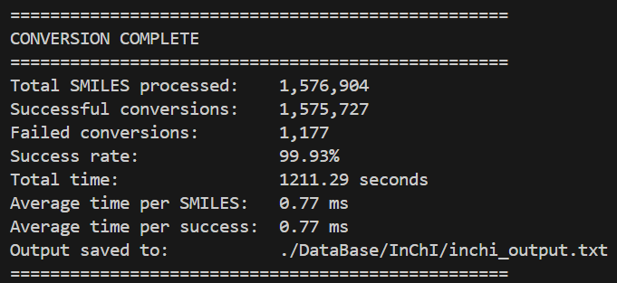
Figure 6 Summary statistics of the SMILES-to-InChI conversion process, including total processed molecules, number of successful and failed conversions, overall success rate, and execution time.

Metabolism-related Database
To obtain metabolism-related data associated with CYP450 enzymes in a structured format, an application was made to DrugBank, an online repository of pharmacological data. After approval for academic use, all their db were readily available, containing structural and pharmacological data of over 1300 small molecule drugs which will serve as backbone for the final data set.
The data obtained from several relational tables was combined to produce a pandas data frame (df) containing a primary key that will be the “DrugBank ID”, which is a unique identifier for each chemical compound. This df also contained the following data:
- “CYPs”: List of all the cytochromes that metabolize it.
- “InChI”
- “SMILES”
Only those drugs that were classified as “SmallMoleculeDrugs” were included in the final df, excluding those with the tag “BiotechDrug” which mostly include proteins and peptides, which are well known to be metabolized as normal proteins, not cytochromes. Any of these drugs tagged with any CYP450 was most likely due to inhibitory interactions not linked to metabolism.
Custom Python functions were developed to automate compound name searches and retrieve canonical SMILES strings. In some cases, the missing SMILES was found directly, while in other cases several different compounds were obtained with the same name. This was because the given name was one that encapsulated several compounds like for example “Omega-3-carboxylic acids”. In these cases, a fake unique “DrugBank ID” was given, and the new lines with the SMILES of each concrete chemical compound was added with the same CYPs as the parent compound. These SMILES representations were then converted into standardized InChI formats using RDKit, seamlessly enriching the dataset with essential molecular descriptors.
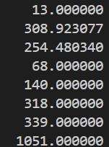
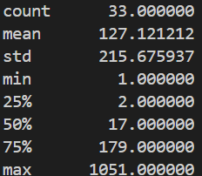
By using the ChemSpiPy API, 15 missing compounds’ SMILES/InChI were obtained, with 3 being flagged as duplicates (Vitamin E/Tocopherol, Cholecalciferol, and dihydroergocryptine) and removed. This gave a final db containing 1369 compounds. In the whole db, 33 different CYP450 isoenzymes were present with a mean appearance frequency of 127 compounds per CYP. The most common isoform, CYP3A4, appears in 1051 compounds while 20 isoforms appear in fewer than 50 compounds (Figure 7A). These low frequency CYP450s were removed from the db as they would not have enough true positives to train and test a model in a reliable and robust manner given the projected 80/20 data split used for training/testing of the models. This threshold of 50 was chosen to produce a test split with at least 10 positive compounds, allowing for a better evaluation of the model’s performance using the selected metrics, ensuring more stable metric readings. This left 13 unique high- to medium-frequency CYP450 with an improved mean of 308 compound appearances (Figure 7B).
A B
Figure 7 CYP450 ‘dict’ descriptors for full db (A) and curated db with threshold = 50 (B). Dict( CYP name : Nº of appearances )

Data source description
- DrugBank [39]: It is a freely accessible online db for academic use that provides comprehensive information on drugs and their molecular targets. It integrates bioinformatics and cheminformatics data, covering chemical, pharmacological, pharmaceutical properties as well as details on related proteins, sequences, structures, and biological pathways. Db downloaded on 28/08/2025.
- Kaggle: It is an open online platform dedicated to data science and ML that hosts publicly accessible datasets, predictive modelling competitions, and collaborative notebooks. Kaggle aggregates datasets contributed by both institutions and individual researchers, covering a wide range of domains including chemistry and bioinformatics. In this work, Kaggle served as the access point for acquiring a pre-processed dataset of drug-like compounds. Db downloaded on 18/02/2026.
- ChEMBL [40]: It is a manually curated, freely accessible database that provides comprehensive bioactivity data for drug-like compounds. It integrates chemical, biological, and pharmacological information, covering from compound structures to bioactivity measurements against biological targets. The data is primarily extracted from the primary medicinal chemistry literature. For this project, ChEMBL served as the fundamental source for the SMILES strings used to train the proprietary InChI embedder, providing the large-scale, high-quality structural data necessary for developing robust chemical representations.

Exploratory data analysis (EDA)
This section provides a structured overview of the data used throughout the project, focusing on its composition, underlying patterns, and potential limitations. The objective is to characterise both the molecular representations and the associated annotations in a way that supports informed decisions in the modelling pipeline, particularly in terms of representation choices, preprocessing steps, and evaluation design.

InChI Database EDA
The analysis of the InChI-based representation reveals several limitations that are important to contextualize the expected performance of the downstream models. These arise primarily from the characteristics of the source data and the constraints of the InChI representation itself, and are discussed here in terms of their practical implications.
A central limitation is the near-complete absence of stereochemical information in the dataset. Only 0.01% of the entries (93 molecules) contain stereochemical annotations in their InChI strings. This can be partially explained by the behaviour of the SMILES-to-InChI conversion process: the use of the \ character, required to encode trans (E) stereochemistry, leads to parsing issues and results in the loss of this information, while the absence of the @ symbol in the original SMILES dataset indicates that chiral centres (R/S stereochemistry) were not present in the original dataset in the first place. Even when considering the 0.07% of SMILES that failed conversion (1177 strings), and assuming in a worst-case scenario that all of them contained stereochemical information, the overall proportion would remain very low. This suggests that the scarcity of stereochemistry is largely a property of the source dataset rather than an artefact introduced during preprocessing. Nevertheless, this remains a relevant limitation, as CYP450-mediated metabolism can be stereoselective, and the model will not be able to accurately capture such effects.
The dataset also exhibits a moderate level of duplication, with approximately 4.7% of entries repeated. Nearly identical duplication rates were observed in the SMILES and InChI db. This indicates that redundancy is primarily inherited from the original database, with only a minor contribution from InChI canonicalization, where different but equivalent SMILES map to the same representation. Some of the most frequently repeated entries correspond to large, peptide-like structures, which likely arise from repeated records in the source data. Unfortunately, these repeated entries were not eliminated in what could have been an improvement of the workflow. However, these types of structures represent only a small fraction of the overall dataset. They are therefore unlikely to significantly influence or bias the model’s performance in a meaningful way. While duplication introduces a degree of frequency bias, where certain molecules are overrepresented, the magnitude of this effect is overall moderate and consistent with typical large-scale chemical databases.
The distribution of sequence lengths in the raw InChI representation shows a clear right-skew, with most molecules concentrated within a relatively narrow range and a long tail corresponding to increasingly complex structures (Figure 8).
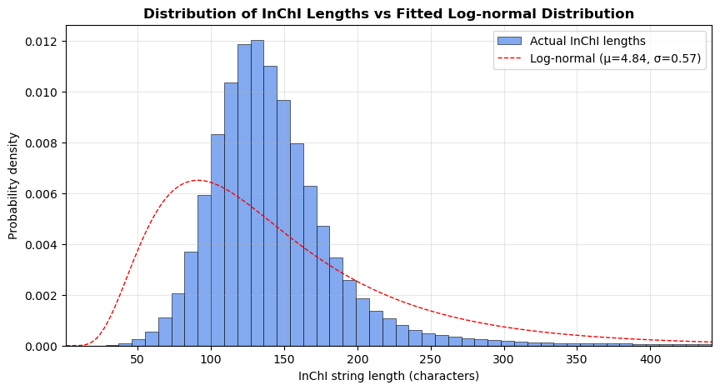
Figure 8 Distribution of InChI string lengths with fitted log-normal distribution. The histogram represents the empirical distribution, with the x-axis truncated at the 99th percentile to improve visual clarity by excluding extreme outliers. The dashed red line corresponds to a fitted log-normal distribution, shown for reference to illustrate the overall shape of the data.
A log-normal distribution provides a reasonable visual approximation of this behaviour, capturing the asymmetry and extended tail observed in the data. This is consistent with the progressive increase in structural complexity as molecules grow.
When applying tokenization, the same overall pattern is preserved, with the distribution maintaining its shape while being rescaled to shorter sequence lengths (Figure 9). This indicates that the transformation does not distort the underlying structural characteristics of the dataset.
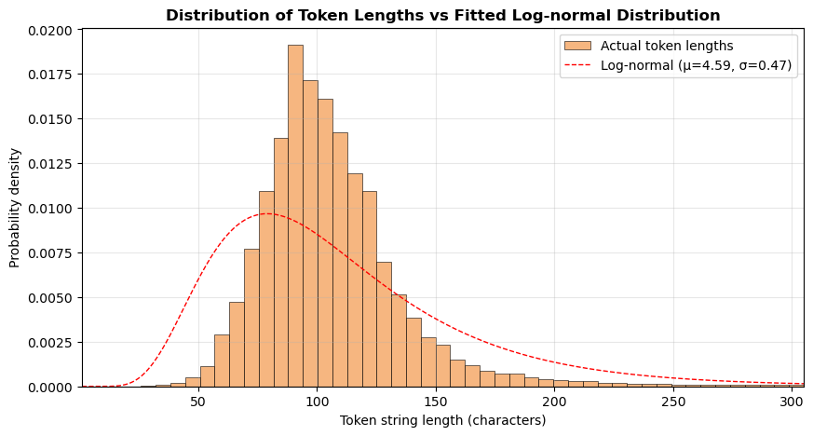
Figure 9 Distribution of tokenized InChI sequence lengths with fitted log-normal distribution. The x-axis is truncated at the 99th percentile for visual clarity. The fitted log-normal curve is shown for reference.
Based on the tokenized sequences, a maximum length of 512 tokens covers more than 99% of the dataset without truncation. The sequences exceeding this threshold correspond predominantly to very large, peptide-like molecules, which are less likely to be primarily metabolized by CYP450 enzymes and instead tend to undergo degradation via proteolytic pathways. As such, the truncation strategy represents a practical trade-off, preserving the vast majority of relevant small-molecule information while maintaining computational efficiency.
With respect to the tokenization process, it is important to note that the Byte-Pair Encoding (BPE) tokenizer learns statistical substructures rather than chemically meaningful units. As a result, individual tokens do not have a direct chemical interpretation. This is an inherent characteristic of data-driven representation learning approaches and is consistent with the broader use of such methods in ML, where predictive performance is typically prioritised over interpretability.
Finally, the scope of the representation is limited to molecules that can be reliably encoded as SMILES and converted into InChI format. Certain classes of compounds, such as metal complexes, are not well supported by this pipeline and are therefore not represented in the dataset. This work is intentionally focused on organic small molecules, which are the primary domain of CYP450-mediated metabolism, and thus this limitation does not significantly affect the applicability of the results within the intended scope.
Overall, the InChI representation is structurally consistent and efficiently tokenized, enabling its use in a ML context. The most relevant limitation is the lack of stereochemical information, which may restrict the model’s ability to capture certain metabolic effects. The dataset also contains moderate duplication and exhibits a long-tail distribution of molecular complexity, both of which are characteristic of real-world chemical databases and are appropriately managed within the pipeline. These factors are well understood and provide a clear context for interpreting the results of the modelling stage.

Metabolism-related Database EDA
The curated metabolism db constitutes the benchmark dataset used for training and evaluating all predictive models developed in this work. Consequently, beyond verifying its integrity after the curation process, it is essential to appropriately characterize the data comprising it, define its biases and limitations and explain what this implies for the model construction.
The final curated dataset comprises 1,368 unique drug molecules annotated with their corresponding metabolizing CYP450 isoenzymes. The distribution of CYP annotations across the dataset is highly imbalanced, with a small number of isoenzymes accounting for most metabolic annotations while many others are represented by only a limited number of compounds. This behaviour is characteristic of biological datasets and results in a pronounced long-tail distribution.
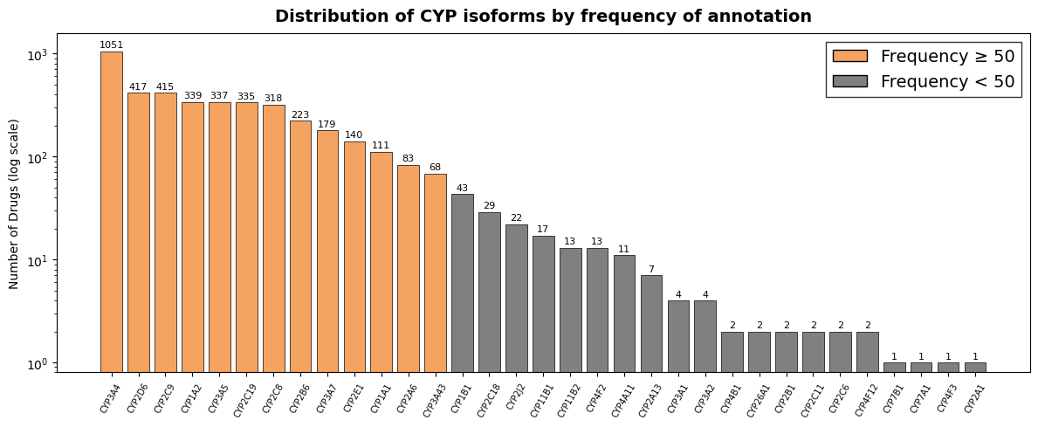
Figure 10 Frequency distribution of CYP450 isoenzyme annotations in the curated metabolism dataset displayed using a logarithmic y-axis.
Among the 33 identified CYP isoforms, CYP3A4 is by far the most frequent enzyme, being associated with 1,051 molecules (76.8%). It is followed by CYP2D6 and CYP2C9, both present in approximately 30% of the dataset, while the remaining enzymes show progressively lower frequencies. At the opposite end of the distribution, numerous CYP isoforms are represented by only a small number of compounds, providing insufficient observations for meaningful model evaluation.
To obtain a statistically robust benchmark, a minimum frequency threshold of 50 annotated molecules was applied, retaining only CYP isoforms with sufficient representation for reliable performance assessment. After filtering, the label space was reduced from 33 to 13 CYP isoforms, while 1,354 of the 1,368 molecules (98.98%) were preserved. Only 14 compounds (1.02%) were excluded because all their metabolic annotations corresponded exclusively to CYPs below the selected threshold.
Drug metabolism is inherently a multi-label problem, as individual compounds are frequently metabolized by several CYP450 isoenzymes simultaneously. To characterize the distribution of metabolic annotations across the dataset the number of CYP450 isoenzymes associated with each compound was analysed. Figure 11 Distribution of the number of CYP450 isoenzymes by which each compound is metabolized after applying the frequency threshold. Figure 11 provides a direct visualization of the number of metabolizing CYPs assigned to each compound and serves to characterize the multi-label nature of the dataset.
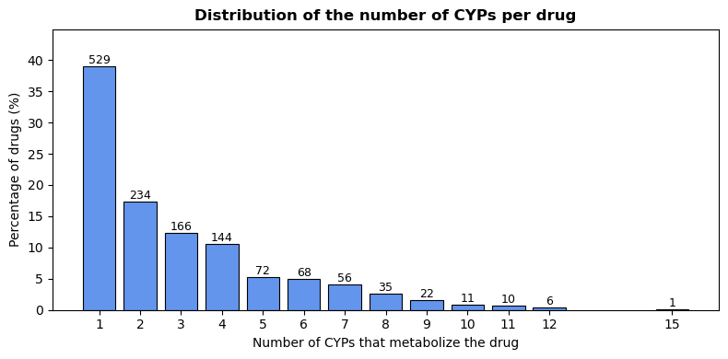
Figure 11 Distribution of the number of CYP450 isoenzymes by which each compound is metabolized after applying the frequency threshold.
Following frequency filtering, the curated benchmark contains an average of 2.97 CYP annotations per compound, with individual molecules ranging from one to fifteen metabolizing enzymes. While 529 molecules (39.1%) are associated with a single CYP isoenzyme, the majority of the dataset (825 molecules, 60.9%) presents two or more metabolic annotations. The compound with the largest number of associated CYPs is Midostaurin, which is annotated with 15 metabolizing isoenzymes. Overall, these results confirm that the benchmark represents a genuine multi-label classification problem rather than a predominantly single-label dataset.
While the previous analysis describes the frequency of individual CYP isoenzymes, it does not capture how metabolic annotations are combined within the same molecule. To explore these relationships, a co-occurrence matrix was generated by counting the number of compounds simultaneously associated with each pair of CYP isoforms.
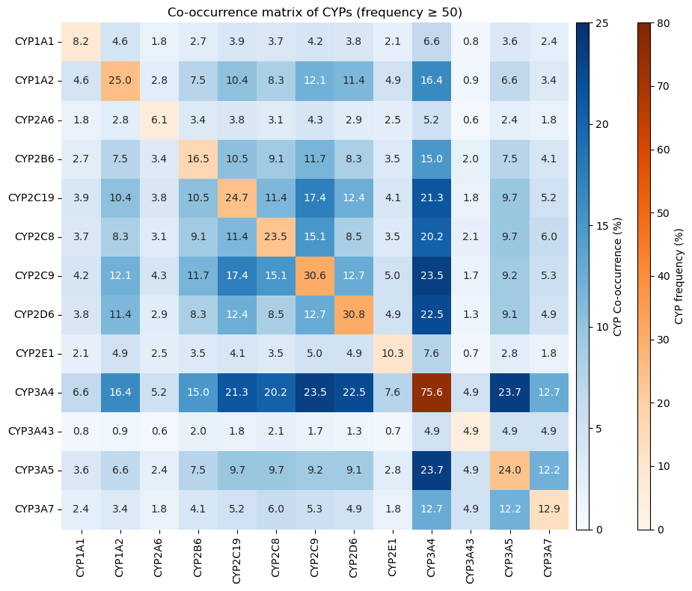
Figure 12 CYP450 co-occurrence heatmap after frequency filtering. The main diagonal (orange) represents the frequency of each retained CYP isoenzyme, while the off-diagonal cells (blue) indicate the percentage of compounds simultaneously metabolized by each pair of CYPs relative to the row CYP.
The resulting heatmap (Figure 12) shows that most CYP pairs exhibit relatively modest levels of co-occurrence, suggesting that the metabolic annotation space remains reasonably heterogeneous despite the dominance of a few highly represented enzymes. The most noticeable associations are observed among members of the CYP2C subfamily (CYP2C8, CYP2C9 and CYP2C19), as well as between CYP3A5 and CYP3A7. These patterns are biologically plausible, as enzymes within the same cytochrome P450 subfamily share a high degree of amino acid sequence [41], which results in highly conserved three-dimensional tertiary structures. Because their catalytic active sites feature near-identical geometry and amino acid residues, they frequently exhibit substrate overlap being able to catalyse related oxidative metabolic reactions in the same substrate compound. Nevertheless, the observed co-occurrences should be interpreted as descriptive characteristics of the dataset rather than evidence of causal biological relationships.
In addition to the distribution of metabolic annotations, the structural characteristics of the molecules themselves are relevant when comparing different molecular representations. One property of particular interest is the presence of explicit stereochemical information within the molecular structures.

Of the 1,368 molecules included in the benchmark, 689 (50.37%) contain explicit stereochemical descriptors within their SMILES representation, while 679 molecules (49.63%) do not. This nearly balanced distribution indicates that the benchmark comprises a comparable proportion of stereochemically defined and non-stereochemical compounds, providing a structurally diverse dataset for evaluating molecular representations.
This observation is also relevant when interpreting the results obtained with the author-trained InChI embedder. As discussed in the previous section, the database used to train this representation contained comparatively limited stereochemical information (see Section 11.3.1). Consequently, although the embedder may still capture general structural features, its ability to exploit stereochemical information present in approximately half of the benchmark molecules may be more limited than that of representations pretrained on datasets with richer stereochemical diversity.
In conclusion, the EDA demonstrates that the curated metabolism database exhibits a pronounced long-tail distribution of CYP annotations while preserving a large number of compounds after frequency filtering. More than 60% of the molecules are associated with multiple metabolizing enzymes, confirming the inherently multi-label nature of the prediction task, and the co-occurrence analysis reveals biologically plausible relationships between several CYP subfamilies without indicating excessive redundancy within the annotation space. Finally, the nearly balanced distribution of molecules with and without explicit stereochemical information highlights the structural diversity of the benchmark and provides useful context for interpreting the comparative performance of the molecular representations evaluated in the following chapters.

Data Preprocessing
This section describes the preprocessing of the curated DrugBank metabolism dataset (1,368 compounds), where molecular structures are encoded into numerical representations for ML. All feature matrices generated in the following subsections are derived from this same set of compounds.

Molecular Fingerprint Generation Using Morgan Algorithm
Firstly, molecular structures were encoded using Morgan fingerprints (ECFP6) derived from their canonical SMILES representations. These were computed using the cheminformatics toolkit RDKit.
Each SMILES string was first parsed into an internal molecular graph object. The Morgan algorithm then iteratively enumerates circular atom environments up to a predefined radius. In this implementation, a radius of 3 was selected, corresponding to ECFP6 (i.e., neighborhoods spanning up to 6 bonds) as previously discussed. These local atomic environments were hashed into fixed-length count vectors of 2,048 dimensions. After processing the curated dataset, this resulted in a fingerprint matrix:
$$X∈N_{0}^{1368×2048}$$
where 1,367 corresponds to the number of compounds in the final dataset and each of the 2,048 columns represents the count of a particular hashed substructure identified within a molecule.
In contrast to binary fingerprints, count-based fingerprints were intentionally selected in order to preserve the multiplicity of structural motifs. Since CYP450-mediated metabolism is often influenced by the frequency of specific functional groups or reactive moieties within a molecule, retaining substructure counts provides a richer representation than simple presence/absence encoding, while maintaining interpretability and computational efficiency.
The resulting fingerprint vectors were assembled into a tab-separated values (.tsv) file structured as a 1,368 × 2,048 numerical matrix. Each row was indexed by the corresponding DrugBank identifier, and columns were labelled from 0 to 2047 to represent individual hashed substructure bins. This structure allows direct compatibility with downstream supervised learning algorithms implemented in scikit-learn and related frameworks.
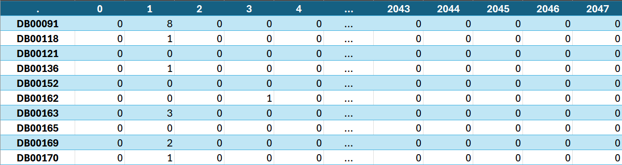
Figure 13 Morgan fingerprint feature matrix (ECFP6, radius = 3) for the curated dataset. Rows correspond to DrugBank IDs; columns represent hashed substructure counts. The resulting matrix has dimensions 1368 × 2048 and contains integer count values.

Molecular Embedding Extraction Using MolE
To complement the fingerprint-based molecular representation, pretrained molecular embeddings were generated using MolE (Molecular Embeddings) [42], an open-source framework designed to produce static vector representations from SMILES strings.
MolE was installed in an isolated virtual environment by following the official instructions provided in its public GitHub repository. The environment was configured locally using a standard Python setup. Although the repository provides GPU-enabled execution as the default configuration, the embedding extraction was performed using CPU-only computation to ensure compatibility with the available hardware.
After installation, a truncated copy of the DrugBank db containing columns ‘id’ and ‘SMILES’, was provided as input to the MolE pipeline. The framework tokenizes each SMILES string, processes it through a pretrained sequence model, and outputs a fixed-length latent representation for each molecule.
The script generated a .tsv file containing the static embeddings as a 1,368 × 1,000 table of float64 values, where each row corresponds to a molecule and each column to an embedding dimension (i.e., $Z∈R^{N×d}$, with $N=1,368$ and $d=1,000$).
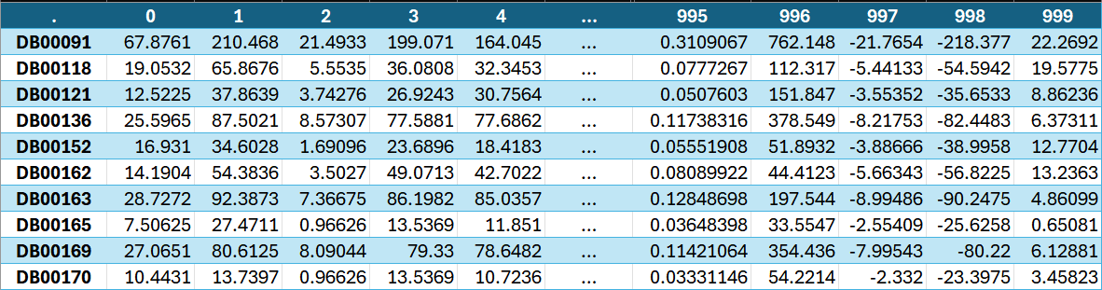
Figure 14 MolE embedding matrix for the curated dataset. Rows correspond to DrugBank IDs; columns represent pretrained embedding dimensions from the MolE transformer. The resulting matrix has dimensions 1368 × 1000 and contains continuous-valued vectors.

Molecular Embedding Extraction Using ChemBERTa
Another set of molecular embeddings were generated using ChemBERTa, a transformer-based language model pretrained on large corpora of SMILES strings. Unlike static fragment-based embeddings, ChemBERTa produces contextualized token representations, allowing the model to capture sequence-dependent chemical information.
The implementation was carried out using the HuggingFace transformers library. A pretrained ChemBERTa model and its associated tokenizer were loaded once at module initialization to ensure computational efficiency and deterministic inference. Each SMILES string was first tokenized into subword units compatible with the model’s vocabulary. To prevent truncation of unusually large molecules, the maximum token length was set to 1024, exceeding the default configuration and ensuring preservation of structural information for macrocyclic or highly complex compounds.
During inference, gradient computation was disabled and the model operated in evaluation mode. The output consists of contextualized token embeddings of dimension 768 for each position in the sequence. To obtain a single fixed-length molecular representation, mean pooling was applied across the token dimension, excluding padding tokens via the attention mask. This procedure yields one embedding vector per molecule.
After processing the curated dataset, the resulting embedding matrix was:
$$X∈R^{1368×768}$$
where 1,368 corresponds to the number of compounds in the final dataset and 768 represents the hidden dimensionality of the ChemBERTa model. The embeddings were exported as a .tsv file structured analogously to previous representations: rows indexed by DrugBank ID and columns labeled from 0 to 767, ensuring compatibility with downstream supervised learning pipelines.
To maintain consistency with MolE embeddings and facilitate concatenation or comparative experiments across learned representations, the output vectors were stored in float64 format.
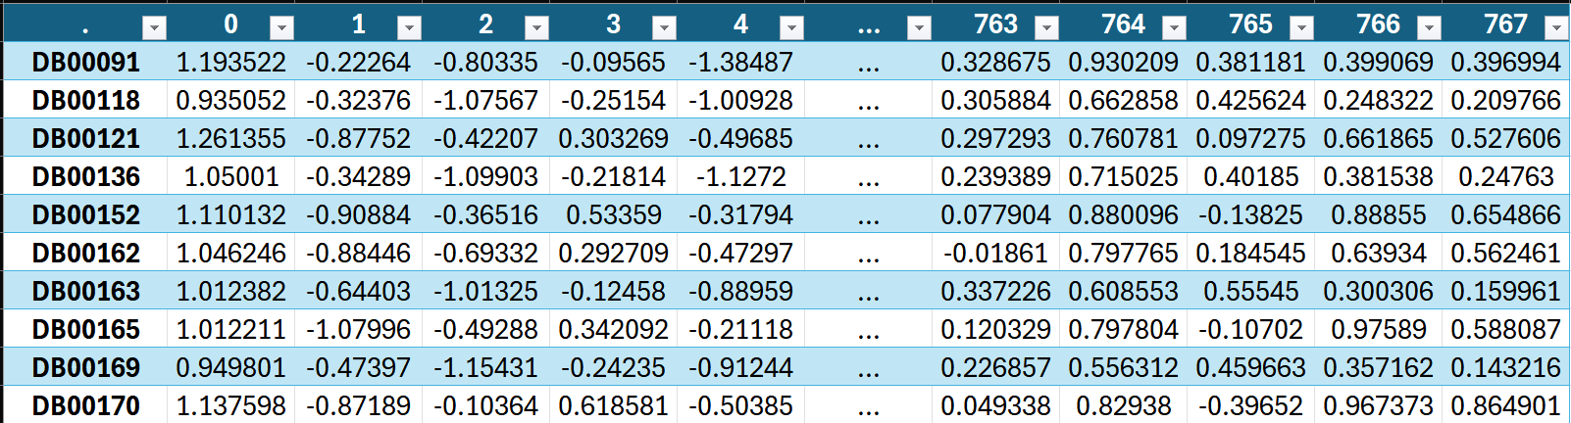
Figure 15 ChemBERTa embedding matrix for the curated dataset. Rows correspond to DrugBank IDs; columns represent pretrained embedding dimensions from the ChemBERTa transformer. The resulting matrix has dimensions 1368 × 768 and contains continuous-valued vectors.

Molecular Embedding Extraction Using Author-Trained InChI embedder
Following the pretraining procedure described in Section 10.3.1, the final InChI-based MLM was successfully trained and exported for downstream use as a feature extractor. The training process completed without instability, reaching convergence within the predefined three epochs under the constrained configuration. The final checkpoint was saved together with the learned tokenizer, enabling deterministic and reproducible embedding extraction.
From a practical standpoint, the most limiting factor during this stage was not model design but hardware capacity. Training was conducted on a laptop’s local GPU with 4GB of VRAM, which imposed strict constraints on batch size, sequence length, and overall architectural scale. Techniques such as mixed-precision training and gradient accumulation were necessary to make the process feasible, effectively trading off training speed for memory efficiency. Despite these optimizations, training remained time-consuming, requiring several hours per epoch and careful monitoring to avoid memory overflows.
In principle, this workload could have been significantly accelerated using cloud-based GPU instances, where access to higher-memory devices (e.g., 16–24GB VRAM) would allow larger batch sizes, longer sequences, and faster convergence. However, the decision was made to carry out the full training pipeline locally. This choice was motivated by considerations of reproducibility, cost control, and full independence of the experimental setup. By avoiding reliance on external infrastructure, the entire workflow, from data preprocessing to model training and embedding extraction, remains fully portable and reproducible on standard hardware.
Once trained, the model was used as a fixed feature extractor. Each molecule from the DrugBank database, represented as an InChI string, was tokenized using the learned Byte-Pair Encoding tokenizer and processed through the transformer encoder in inference mode. Consistent with the training configuration, sequences were truncated to a maximum length of 512 tokens to ensure compatibility with the learned positional embeddings.
The model produces a sequence of token-level embeddings of dimension 384 for each InChI string. To obtain a single representation per molecule, these token embeddings are averaged using mean pooling, considering only valid (non-padding) tokens. Formally:
$$h_{i}​=\frac{1}{T_{i}}\sum_{j=1}^{T_{i}}{e_{j}}​$$
where $e_{j}∈R^{384}$is the embedding of token $j$, and $T_{i}$is the number of valid tokens in molecule $i$. The resulting vector $h_{i}∈R^{384}$represents the molecule in the embedding space.
As with the other embedding methods, the resulting vectors were stored in float64 format and exported as a tab-separated values (.tsv) file, with rows indexed by DrugBank ID and columns labeled from 0 to 383. This ensures full compatibility with downstream ML pipelines and enables direct comparison with alternative representations.
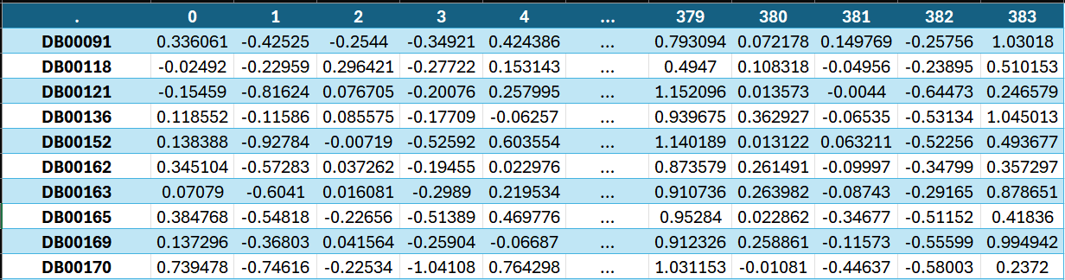
Figure 16 InChI-based embedding matrix for the curated dataset. Rows correspond to DrugBank IDs; columns represent embedding dimensions from the author-trained InChI transformer. The resulting matrix has dimensions 1368 × 384 and contains continuous-valued vectors.

Feature Selection
To ensure a fair and interpretable comparison between molecular representations, no explicit feature-selection procedure was applied prior to model training. All molecular descriptors generated during the representation stage were retained in their complete form and used directly as inputs to the predictive models. This decision was made to ensure that performance differences could be attributed primarily to the representations themselves rather than to additional feature-engineering choices.
Consequently, no filter-based methods (e.g., variance or correlation filtering) or dimensionality-reduction techniques such as Principal Component Analysis were employed. Likewise, no feature scaling or normalization was incorporated as part of the feature-selection stage, although it is important to note that some of the evaluated algorithms incorporate mechanisms that can implicitly reduce the influence of less informative variables during training. Specifically, LR may perform coefficient shrinkage through L1 (Lasso) and L2 (Ridge) regularization, but these processes occur as part of model fitting and were not considered a feature-selection stage within the benchmark per se. Meanwhile, RF and XGBoost naturally prioritize informative features when constructing decision trees but again, this is not considered a separate feature-selection stage per se.
For the Morgan fingerprint representation, all 2,048 count-based ECFP6 features were retained. Such sparse, high-dimensional descriptor spaces are routinely used in cheminformatics and can be handled directly by both linear and tree-based ML algorithms, so no specific feature selection mechanism was required.
For the embedding-based representations, the complete latent vectors produced by each encoder were preserved without modification. Unlike handcrafted fingerprints, these representations already constitute compressed feature spaces learned during pretraining so applying additional dimensionality reduction could inadvertently remove information already encoded by the embedding models hindering a fair assessment of their representational capacity.
Overall, all representation-model combinations were trained using the complete feature spaces generated during preprocessing.

Data Splitting
All experiments were conducted using a fixed data partitioning strategy. Since the objective of this work was to evaluate the effect of different molecular representations and predictive models, it was essential that every experiment be trained and evaluated on exactly the same molecules. Consequently, the data splits were generated once and subsequently reused throughout the entire study.
The curated dataset was divided into an 80% training set and a 20% independent test set using iterative multilabel stratification through the MultilabelStratifiedShuffleSplit algorithm. Unlike conventional stratification methods, this approach attempts to preserve the distribution of all CYP labels simultaneously, which is particularly important in multi-label problems where a single molecule may be associated with multiple isoenzymes. The resulting test set remained completely isolated during model selection and hyperparameter optimisation and was only used for the final performance assessment.
CV was performed exclusively within the training partition. A three-fold iterative multilabel stratified scheme was generated using MultilabelStratifiedKFold, ensuring that each fold retained a label distribution similar to that of the complete training set. To improve the stability of the evaluation process, an additional validation step was incorporated during fold generation. The code was designed to iterate through candidate random seeds and test each until every validation fold contained at least ten positive examples for each included CYP isoform. This threshold was selected to reduce the risk of highly unstable MCC estimates caused by extremely sparse validation subsets. Nevertheless, the first seed tested gave a satisfactory data partition, so no other seeds had to be tested. Additionally, CYP classes with fewer than five positive examples in either the training or test partitions were excluded from the benchmark, as performance estimates based on such limited numbers become unreliable and difficult to interpret.
The split generation process used the Morgan fingerprint dataset as a reference. However, the resulting train/test partitions and CV folds were defined exclusively by molecule identifiers and were therefore independent of any particular representation. The same partitions could consequently be applied without modification to the ECFP6 fingerprints, MolE embeddings, ChemBERTa embeddings, and the author-trained InChI embeddings.
Once generated, the train/test partitions, CV folds, and list of included CYP isoforms were frozen and stored for subsequent reuse. All representation-model combinations, including the Majority Predictor, Logistic Regression, Random Forest, and XGBoost pipelines, loaded the same predefined molecule identifiers and fold assignments. This eliminated variability arising from repeated random partitioning and ensured that any observed differences in performance reflected the representations and learning algorithms themselves rather than differences in the underlying data splits.
To further support reproducibility, the splitting procedure was implemented as a dedicated and reusable component of the benchmark pipeline. The generated partitions were saved in the benchmark_splits.joblib file and subsequently loaded by all training scripts rather than being regenerated independently. A human-readable export of the same information is provided (see Annex), allowing the complete benchmark partitioning scheme to be inspected and reproduced.

Model Training
The training pipeline was executed independently for each combination of molecular representation and predictive model using the frozen data partitions described in section 11.6. Hyperparameter optimisation and CYP-specific threshold selection were performed according to the methodology previously described, ensuring that all experiments were conducted under identical conditions and could be compared directly.
All representation-model combinations completed the training process successfully. No CYP isoforms had to be excluded after the benchmark splits were generated, and no failures were encountered during hyperparameter optimisation or final model fitting. However, a subset of the LR models trained with the saga solver reached the predefined maximum number of iterations (5000) before satisfying the convergence criterion, generating convergence warnings. These warnings were observed across all molecular representations, being most frequent for the MolE embeddings and least frequent for the Morgan fingerprints. Since the optimisation process still produced valid models, these configurations were retained in the benchmark. Nevertheless, it should be considered that some of these models may not have reached the optimum solution, potentially leading to slightly suboptimal predictive performance. Increasing the maximum number of iterations would likely reduce the number of warnings, but this was considered an unnecessary increase in computational cost given the objectives and scope of the benchmark.
Table 4 Frequency of saga convergence warnings by molecular representation during LR training.
Representation | SAGA CV fits | Convergence warnings | Warning rate
Morgan (ECFP6) | 312 | 7 | 2.2%
MolE | 312 | 266 | 85.3%
ChemBERTa | 312 | 100 | 32.1%
InChI | 312 | 16 | 5.1%

For each experiment, the optimal hyperparameter configuration identified during CV was automatically recorded and stored together with the corresponding CYP-specific decision thresholds. These artefacts were subsequently reused during the final evaluation stage, ensuring that all reported test set results were obtained using the best configuration identified during model selection. The resulting files are included in the supplementary materials in a human-readable format.
Once the optimal configurations had been identified, the corresponding models were retrained using the complete training partition and subsequently evaluated on the independent test set.

Model Evaluation and Validation
All molecular representations and learning algorithms were evaluated using the same train-test partition, identical hyperparameter optimisation strategy and the same evaluation metrics, ensuring a fair comparison between experiments. Performance assessment was carried out using the metrics introduced in Section 10.4.3, while model selection and threshold optimisation followed the cross-validation procedure described in Section 10.4.4. The following is a summary of the benchmark results.

Majority Baseline

The majority class predictor was evaluated as a minimal reference to establish the level of performance obtained without learning any relationship between molecular structure and CYP metabolism. As expected, the baseline achieved a Macro MCC of 0, confirming the absence of discriminative capability. Since the model always predicts the majority class, it cannot correctly distinguish positive from negative samples, resulting in an MCC equal to zero.
Table 5 summarises the baseline performance using the three evaluation metrics employed throughout this work.
Table 5 Performance of the majority class predictor.
Metric | Value
Macro mcc | 0.000
Micro-F1 | 0.381
Hamming loss | 0.183

Although the baseline attains a non-zero Micro-F1 score and a relatively low Hamming Loss, these values arise from predicting the majority class independently for each CYP rather than from learning meaningful relationships between molecular structure and metabolism. In the present dataset, the majority class is negative for most CYP isoenzymes but positive for CYP3A4, resulting in a small number of correctly predicted positive labels and, consequently, a non-zero Micro-F1 score. Nevertheless, the baseline fails to discriminate between positive and negative samples beyond the class priors, as reflected by its Macro MCC of zero.
All supervised models achieved positive Macro MCC values and higher Micro-F1 scores than the majority predictor, demonstrating genuine discriminative ability. However, every supervised model also produced a higher HL than the baseline. This behaviour reflects the expected trade-off between minimising the total number of prediction errors and correctly identifying minority classes. As the supervised models actively predict positive CYP annotations, they inevitably introduce additional false positives while substantially reducing false negatives. Therefore, throughout the remainder of this work, Macro MCC is considered the primary indicator of predictive performance, with the secondary metrics serving only as complementary measures.

Threshold Optimisation
Following model selection, as previously described in Section 10.4.4, τ values were independently optimised for each CYP isoenzyme and model-representation combination. The distribution of values is presented in Figure 17, while Figure 18 summarises the individual statistics for each CYP.
Only four τ values (0.1, 0.3, 0.5 and 0.7) were possible across all experiments. The most frequently chosen values were 0.7 (30.8%) and 0.1 (26.9%), followed by 0.3 (26.3%) and 0.5 (16.0%), indicating that the optimisation procedure slightly favoured more extreme τ over intermediate values.
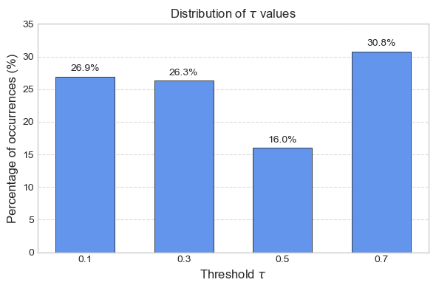
Figure 17 Distribution of τ across all models and molecular representations. The bar height indicates the percentage of times each τ value was chosen.
These results also revealed clear differences between CYP isoenzymes. CYP3A5 and CYP3A7 consistently received a threshold of 0.7 across every evaluated model, exhibiting zero variability. Conversely, CYP1A2 and CYP2A6 showed the largest variation in the selected thresholds, suggesting that their optimal decision boundaries depend more strongly on the underlying model and molecular representation.
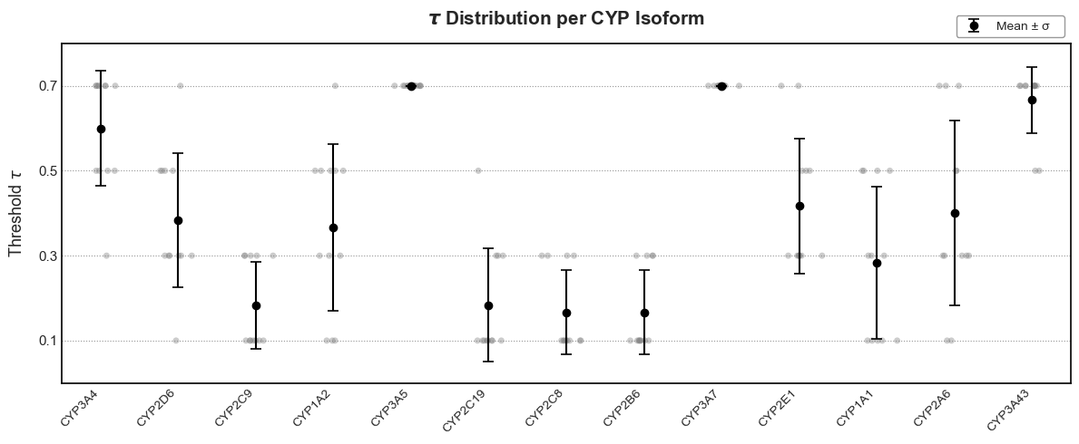
Figure 18 τ selected for individual CYP isoforms. Gray points show all raw threshold choices from different models and representations. Black dots with error bars indicate the mean threshold ± one standard deviation for each CYP.
Overall, these observations indicate that threshold optimisation produced CYP-specific decision boundaries that remained largely consistent across the evaluated models, supporting the use of independent threshold optimisation within the benchmark pipeline.

Overall Benchmark Performance
Table 6 presents the primary benchmark results measured using Macro MCC on the independent test set. The results are organised by molecular representation and learning algorithm, together with the mean and standard deviation across the three evaluated models.
Table 6 Test-set Macro MCC obtained by each model-representation* combination.
Model  Repres.* | LR | RF | XGBoost | Mean ± σ
ECFP6 | 0.218 | 0.224 | 0.204 | 0.216 ± 0.010
MolE | 0.194 | 0.214 | 0.240 | 0.216 ± 0.023
ChemBERTa | 0.107 | 0.129 | 0.116 | 0.117 ± 0.011
InChI | 0.122 | 0.120 | 0.153 | 0.132 ± 0.018
Mean ± σ | 0.160 ± 0.054 | 0.172 ± 0.055 | 0.178 ± 0.055

These results show that MolE and Morgan fingerprints obtained the highest average Macro MCC, with mean values of 0.216 and 0.215 respectively, considerably outperforming the InChI and ChemBERTa representations. The relatively small standard deviations observed for both MolE and Morgan also indicate stable performance across the evaluated learning algorithms.
Considering the individual model-representation combinations, the highest Macro MCC was obtained by MolE combined with XGBoost (0.240), while the best Morgan result was achieved using Random Forest (0.224). In contrast, both InChI and ChemBERTa consistently produced lower MCC values regardless of the selected learning algorithm.
Across the evaluated architectures, XGBoost achieved the highest Macro MCC for three of the four molecular representations, whereas Random Forest produced the strongest result for Morgan fingerprints. Logistic Regression generally obtained slightly lower scores, although the differences between architectures remained relatively modest compared with the differences observed between molecular representations.

Secondary Evaluation Metrics
The benchmark was additionally evaluated using Micro-F1 and HL in order to complement the primary Macro MCC analysis.
Table 7 Test-set Micro-F1 obtained by each model-representation* combination.
Model  Repres.* | LR | RF | XGBoost
ECFP6 | 0.495 | 0.504 | 0.474
MolE | 0.396 | 0.487 | 0.533
ChemBERTa | 0.409 | 0.423 | 0.437
InChI | 0.453 | 0.426 | 0.462

Table 8 Test-set Hamming Loss obtained by each model-representation* combination. Lower is better.
Model  Repres.* | LR | RF | XGBoost
ECFP6 | 0.291 | 0.279 | 0.335
MolE | 0.405 | 0.286 | 0.216
ChemBERTa | 0.439 | 0.441 | 0.404
InChI | 0.364 | 0.408 | 0.323

The results for Micro-F1 closely follow those obtained using Macro MCC. MolE and Morgan consistently achieved the highest Micro F1 scores, particularly when combined with the ensemble-based learning algorithms, while InChI and ChemBERTa produced lower values across all evaluated models.
HL exhibited a different behaviour. Although lower values indicate fewer total classification errors, every supervised model produced a higher Hamming Loss than the majority baseline. This apparent contradiction reflects the fact that the supervised models actively predict minority CYP labels, thereby increasing the number of false positives while substantially improving class discrimination. Consequently, HL should be interpreted cautiously in the context of highly imbalanced multi-label classification problems and is considered a complementary metric rather than the primary criterion for model comparison.
Overall, the secondary metrics support the trends observed using Macro MCC while reinforcing the importance of evaluating discriminative ability rather than overall classification accuracy alone.

Per-CYP Performance
To further investigate benchmark performance at the label level, MCC was analysed individually for each CYP isoenzyme. Figure 19 presents the per-CYP MCC obtained for every model-representation combination together with the average performance across all evaluated experiments, providing an overview of both CYP-specific variability and overall prediction difficulty.
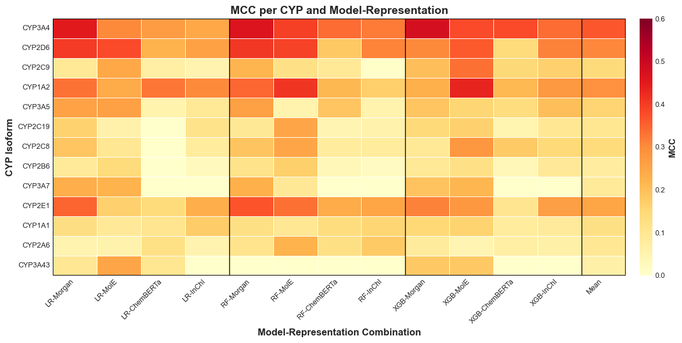
Figure 19 Heatmap of MCC for each CYP isoform across all model-representation combinations.
Rows correspond to CYP isoforms, columns to model-representation pairs. The rightmost column shows the mean MCC per CYP. Colour intensity indicates MCC magnitude (light = low, dark = high), with the scale fixed from 0 to 0.6 for visual consistency.
Performance varied substantially between CYP isoenzymes. CYP3A4 achieved the highest average MCC (0.364), followed by CYP2D6 (0.306) and CYP1A2 (0.291), indicating consistently stronger predictive performance across models and molecular representations. In contrast, CYP2B6 (0.078), CYP3A7 (0.089) and CYP2A6 (0.098) produced the lowest average MCC values throughout the benchmark.
The relative ordering of the molecular representations remained broadly consistent across the individual CYPs. MolE and Morgan fingerprints generally produced higher MCC values than InChI and ChemBERTa for most isoenzymes, although the magnitude of the differences varied depending on the CYP considered. Greater variability between model architectures was also observed for certain CYPs, whereas others exhibited relatively consistent performance regardless of the selected learning algorithm.
These results may suggest that prediction performance is strongly dependent on the target CYP isoenzyme, highlighting that benchmark performance cannot be fully characterised using only aggregate evaluation metrics. The implications of these trends and their relationship with the molecular representations and learning algorithms are examined in the following section.

Comparative Analysis
The results presented in the previous section enables the evaluated molecular representations and ML algorithms to be compared under identical preprocessing, model selection and validation conditions. As every experiment followed the same training-validation protocol and was assessed using the same independent test partition, the observed differences can be majorly attributed to the evaluated molecular representations and predictive models rather than inconsistencies in the experimental methodology. This section synthesises the benchmark results, discusses the main performance trends, and relates the findings to the objectives established at the beginning of this work.

Comparison of Molecular Representations
The principal objective of this study was to establish a fair internal benchmark comparing multiple molecular representations for multi-label CYP450 metabolism prediction. Across the evaluated experiments, two clear performance groups emerged.
Morgan fingerprints and MolE consistently achieved the highest Macro MCC values across all three learning algorithms, with mean scores of 0.215 and 0.216 respectively. Although MolE produced the highest individual benchmark result when combined with XGBoost, the average difference between the two representations was negligible, suggesting comparable predictive capability under the evaluated conditions. In contrast, both ChemBERTa and the custom InChI embeddings produced substantially lower Macro MCC values regardless of the selected learning algorithm.
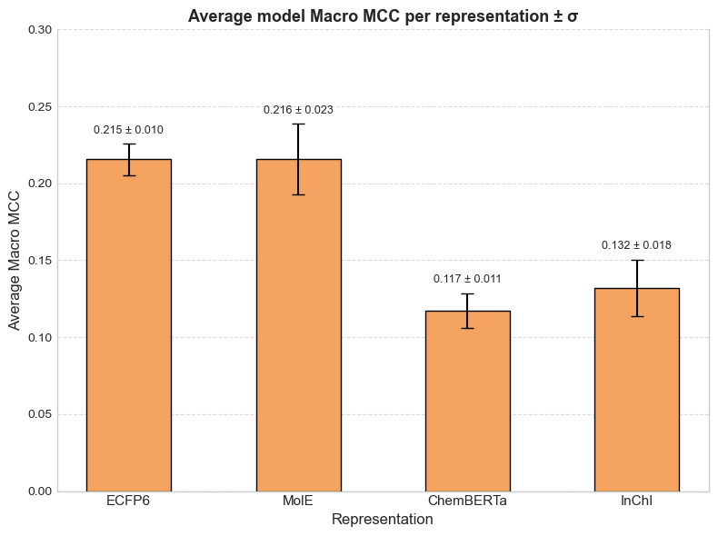
Figure 20 Average Macro MCC by molecular representation (error bars indicate the standard deviation across learning algorithms).
Morgan fingerprints and MolE achieved almost identical average Macro MCC values, clearly separating them from the InChI and ChemBERTa representations. While Morgan fingerprints exhibited the smallest variability across the evaluated learning algorithms, MolE showed a greater dependence on the selected architecture, reflected by its larger standard deviation. This increased variability is largely attributable to the particularly strong performance obtained when MolE was combined with XGBoost, which produced the highest individual benchmark result.
These results suggest that, within the scope of this benchmark, differences associated with molecular representation were more pronounced than those observed between the evaluated learning algorithms. Although no representation achieved high predictive performance in absolute terms, the benchmark consistently identified Morgan fingerprints and MolE as the most effective encodings for this prediction task.

Influence of the ML Algorithm
While molecular representation emerged as the dominant factor affecting predictive performance, several consistent trends were also observed across the evaluated learning algorithms.
Interestingly, XGBoost produced the highest Macro MCC for three of the four evaluated representations, although the magnitude of its advantage varied depending on the molecular encoding. The largest improvement was observed for MolE, whereas Morgan fingerprints achieved comparable performance across all three ML algorithms, with RF marginally producing the strongest result.
Importantly, the relative ordering of the ML algorithms varied only modestly between representations, and no single architecture consistently dominated every experiment. The comparatively small performance differences between LR, RF and XGBoost contrast with the larger performance differences observed between molecular representations, reinforcing the importance of selecting an appropriate molecular encoding before considering increasingly complex predictive models.
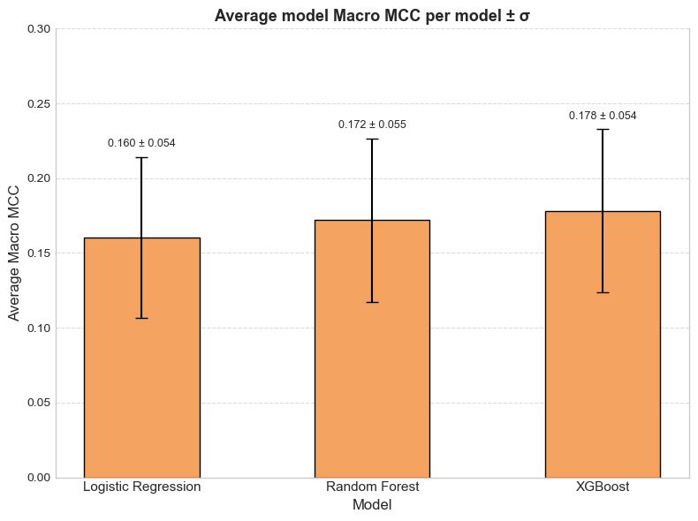
Figure 21 Average Macro MCC by ML algorithm (error bars indicate the standard deviation across representations).
Nevertheless, looking deeper into these results also revealed several subtler interactions between molecular representation and learning algorithm that are not immediately apparent from the overall benchmark scores. Although the choice of molecular representation remained the dominant factor influencing predictive performance, the relative behaviour of the learning algorithms depended to some extent on the representation being evaluated.
The clearest example is provided by the MolE embeddings. While LR and RF achieved comparable Macro MCC values (0.194 and 0.214, respectively), XGBoost increased performance to 0.240, representing the largest improvement observed for any model-representation combination. In contrast, Morgan fingerprints exhibited remarkably consistent performance across all three algorithms (0.218, 0.224 and 0.204 for LR, RF and XGBoost, respectively), with only minor differences between them. These observations suggest that the richer feature space encoded by MolE may benefit more from models capable of capturing non-linear relationships, whereas the information contained in Morgan fingerprints can already be exploited effectively by comparatively simpler classifiers.
A second observation concerns the robustness of the evaluated algorithms. RF consistently produced competitive results across all four molecular representations, never achieving either the highest or the lowest results. Although it was not the best-performing algorithm overall, its relatively uniform behaviour indicates that it represents a robust compromise when the optimal representation is unknown or when extensive model selection is impractical.
Finally, the poorer-performing ChemBERTa and exploratory InChI embeddings remained consistently below Morgan fingerprints and MolE regardless of the learning algorithm employed. The relatively small differences between LR, RF and XGBoost for these representations suggest that their performance was limited primarily by the information captured by the embeddings themselves rather than by the expressive capacity of the downstream classifier. Consequently, for the benchmark considered in this work, improvements in molecular representation appear to offer greater potential for increasing predictive performance than further increasing model complexity alone.

Evaluation of the Exploratory InChI Representation
A secondary objective of this work was to investigate whether a language model pretrained exclusively on InChI strings could provide a useful alternative to existing molecular representations. Unlike the benchmark comparison between Morgan fingerprints, MolE and ChemBERTa, this experiment was intentionally framed as an exploratory line of inquiry rather than a primary contribution.
Under the evaluated conditions, the InChI embeddings generally outperformed ChemBERTa but remained clearly below both Morgan fingerprints and MolE across all three learning algorithms (Table 6, Table 7, Table 8). These results indicate that the proposed representation was capable of capturing chemically meaningful information, although not at a level sufficient to compete with the strongest benchmark representations.
Several factors should be considered when interpreting these findings. As discussed in Section 10.3.1.3, the transformer model was pretrained on a substantially smaller corpus than existing large-scale molecular language models and employed a lightweight architecture constrained by the available computational resources. Furthermore, the exploratory data analysis demonstrated that stereochemical information was present in only a very small fraction of the curated dataset, limiting one of the principal theoretical advantages of the InChI representation. Consequently, the present benchmark should not be interpreted as a definitive evaluation of InChI as a molecular representation, but rather as an initial assessment of whether a comparatively simple and resource-constrained InChI pretraining strategy can provide useful predictive information for this task.
Although the resulting embeddings did not reach the performance of the strongest benchmark representations, they consistently achieved meaningful predictive performance and outperformed ChemBERTa across the evaluated learning algorithms. Consequently, the exploratory objective of this work can be considered successful in demonstrating the feasibility of this approach rather than establishing a new state-of-the-art molecular representation. The results suggest that domain-specific pretraining on InChI strings can capture useful chemical information despite being developed under constrained conditions, while also highlighting several avenues for future improvement, including larger pretraining corpora, richer stereochemical annotations, and more extensive model optimisation.

CYP-dependent Prediction Behaviour
The per-CYP analysis revealed substantial variability in predictive performance across the evaluated isoenzymes. Figure 19 showed that this variability remained consistent across virtually all model-representation combinations, suggesting that prediction difficulty depends strongly on the target CYP.
To investigate whether these differences were associated with the amount of available training data, the average Macro MCC obtained for each CYP was compared with the number of positive training samples (Figure 22).
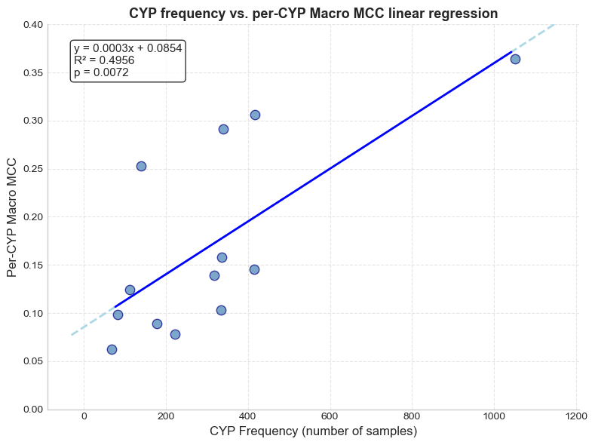
Figure 22 Relationship between the average per-CYP Macro MCC and the number of positive samples available for each CYP. The dashed line represents the least-squares linear regression (R² = 0.4956, p = 0.0072).
The apparent association is substantially weakened when CYP3A4, the most frequent isoenzyme, is excluded from the analysis (R² = 0.23, p = 0.111).
A moderate positive association was observed between CYP frequency and predictive performance (R² = 0.50, p = 0.007), indicating that isoenzymes represented by larger numbers of positive examples generally achieved higher MCC values. However, this relationship should be interpreted cautiously. The regression is substantially influenced by CYP3A4, which constitutes a high-leverage observation owing to its markedly greater number of positive samples compared with all remaining CYPs. When CYP3A4 is excluded from the analysis, the relationship weakens considerably (R² = 0.23, p = 0.111), indicating that the observed trend is suggestive rather than robust.
Despite this limitation, the scatter plot reveals several informative deviations from the overall trend. CYP2D6, CYP2E1 and CYP1A2 consistently achieved higher Macro MCC values than would be expected based solely on their frequency, suggesting that these isoenzymes may exhibit molecular patterns that are comparatively easier for the evaluated representations and learning algorithms to capture. In contrast, several CYPs closely followed or fell below the fitted regression line, indicating that increasing sample size alone is unlikely to explain the differences observed across the benchmark.
Overall, these findings suggest that the availability of annotated training data contributes to predictive performance but does not fully determine it. Additional factors, including the structural characteristics of the substrates associated with individual CYP isoenzymes, are also likely to influence prediction difficulty. Further investigation using larger datasets would be required to establish the relative contribution of these factors with greater confidence.
The τ optimisation results are consistent with these observations. In particular, CYP3A5 and CYP3A7 consistently received the highest probability threshold across all evaluated experiments, indicating that the optimisation procedure favoured conservative predictions for these isoenzymes. Nevertheless, both remained among the lowest-performing CYPs, suggesting that adjusting the decision threshold alone is insufficient to compensate for their greater prediction difficulty.

Generalisation and Benchmark Robustness
An additional observation emerging from these results concerns the relationship between CV and independent test performance. Across all evaluated model-representation combinations, the Macro MCC obtained during CV was consistently higher than that measured on the held-out test partition, with decreases ranging from approximately 0.21 to 0.33 MCC units.
Table 9 Comparison between mean CV Macro MCC and independent test Macro MCC for all model-representation combinations.
Model | Representation | Mean CV MCC | σ CV MCC | Test Macro MCC | Test – CV
LR | ECFP6 | 0.4437 | ± 0.0168 | 0.2182 | -0.2255
 | MolE | 0.4114 | ± 0.0365 | 0.1936 | -0.2178
 | ChemBERTa | 0.3713 | ± 0.1202 | 0.1069 | -0.2644
 | InChI | 0.4132 | ± 0.0361 | 0.1224 | -0.2907
RF | ECFP6 | 0.4704 | ± 0.0081 | 0.2241 | -0.2463
 | MolE | 0.4582 | ± 0.0035 | 0.2138 | -0.2444
 | ChemBERTa | 0.4358 | ± 0.0055 | 0.1292 | -0.3066
 | InChI | 0.4467 | ± 0.0026 | 0.1205 | -0.3262
XGBoost | ECFP6 | 0.4589 | ± 0.0085 | 0.2041 | -0.2548
 | MolE | 0.4533 | ± 0.0045 | 0.2396 | -0.2136
 | ChemBERTa | 0.3837 | ± 0.0142 | 0.1162 | -0.2675
 | InChI | 0.4147 | ± 0.0067 | 0.1532 | -0.2615

Although this reduction is substantial, it exhibited a remarkably consistent pattern across all learning algorithms and molecular representations. The relative ranking of the evaluated approaches remained essentially unchanged, indicating that the observed performance differences between representations were preserved despite the decrease in absolute MCC values. Furthermore, hyperparameter optimisation produced comparatively small improvements within each model-representation combination, with most candidate configurations differing by only a few hundredths of Macro MCC during cross-validation. Together, these observations suggest that the reduction reflects a generalisation gap common to the benchmark rather than indicating severe overfitting of any individual model or molecular representation.

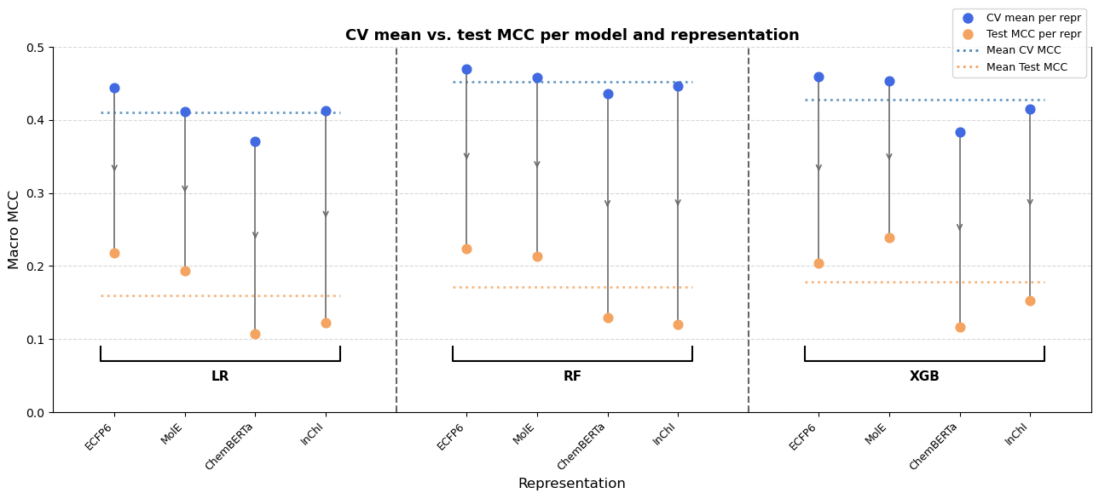
Figure 23 Comparison between CV and test set performance across machine learning models and molecular representations.
Figure 23 illustrates the consistency of this behaviour. Every evaluated model-representation combination exhibited a decrease in Macro MCC when moving from CV to the independent test set. The decrease was generally smaller for Morgan fingerprints and MolE, particularly when combined with XGBoost, whereas ChemBERTa and the exploratory InChI embeddings showed somewhat larger drops across the evaluated learning algorithms. Despite these differences, the overall pattern remained remarkably uniform, reinforcing that the benchmark conclusions are robust to the transition from model selection to independent evaluation.
Several characteristics of the present benchmark may contribute to this behaviour. The study was conducted on a relatively small and highly imbalanced multi-label dataset, where performance estimates are naturally subject to greater variability than in larger benchmarks. In addition, the cross CV and independent test scores were obtained from different data partitions, meaning that some variation between the two estimates is expected, particularly when working with limited sample sizes. Consequently, part of the observed reduction in Macro MCC may reflect the combined effects of sampling variability, optimistic CV estimates arising from model selection, and the specific train–test partition used in this benchmark, rather than indicating a methodological issue or systematic overfitting.
Rather than weakening the benchmark, this observation reinforces the importance of maintaining a strictly independent test partition throughout model development. Although the absolute predictive performance decreased, the consistent preservation of the order between molecular representations and learning algorithms suggests that the benchmark is robust for comparative evaluation, even though absolute predictive performance decreases when assessed on previously unseen data.

Implications for Molecular Representation and Model Selection
Beyond the comparison of individual benchmark scores, the present results provide several practical observations that may inform the design of future molecular machine learning studies targeting CYP450 metabolism.
From the perspective of molecular representation, the results reinforce the continued competitiveness of established descriptor-based approaches. Morgan fingerprints consistently achieved one of the highest predictive performances while remaining largely insensitive to the choice of downstream learning algorithm. Combined with their low computational cost, straightforward generation, and well-established interpretability, these characteristics suggest that fingerprint-based representations remain a strong and practical choice for molecular property prediction, particularly when training data or computational resources are limited.
Conversely, the embedding-based representations demonstrated that representation learning alone does not guarantee improved predictive performance. While MolE achieved the highest overall Macro MCC when combined with XGBoost, its performance depended more strongly on the learning algorithm than did Morgan fingerprints. This behaviour suggests that richer learned embeddings may encode structural relationships that require models capable of capturing more complex, non-linear decision boundaries. Consequently, the benefits of learned molecular embeddings should be considered jointly with the choice of downstream predictive model rather than in isolation.
The exploratory InChI representation further illustrates this point. Although it did not reach the performance of Morgan fingerprints or MolE, it consistently captured useful predictive information despite being developed under substantially more constrained conditions than the established pretrained models. These results demonstrate the feasibility of this approach and highlights several avenues for future investigation, including larger pretraining corpora, more expressive transformer architectures and datasets containing richer stereochemical information.
The benchmark also highlights that the influence of the learning algorithm depends on the representation being employed. Differences between LR, RF and XGBoost were generally smaller than those observed between molecular representations, indicating that representation choice remained the primary determinant of predictive performance. Nevertheless, meaningful interactions between representations and classifiers were evident. Morgan fingerprints produced competitive results across all three learning algorithms, whereas MolE exhibited its largest improvement when combined with XGBoost. These observations suggest that simpler descriptor-based representations may already expose sufficiently informative features for relatively simple classifiers, while richer learned embeddings may benefit from models with greater expressive capacity.
Among the evaluated algorithms, RF provided the most consistent performance across the four molecular representations, never substantially outperforming nor underperforming the remaining methods. LR, despite its simplicity, remained highly competitive when paired with Morgan fingerprints, approaching the performance of considerably more complex ensemble methods while requiring substantially lower computational cost. XGBoost, in turn, achieved the highest individual benchmark score and appeared to extract additional predictive value from the richer embedding-based representations, indicating that greater model complexity may become advantageous when sufficiently informative molecular representations are available.
Overall, these findings suggest that improvements in molecular representation are likely to yield larger gains than increasing classifier complexity alone. At the same time, the benchmark demonstrates that representation and model selection should not be treated as independent design decisions. Instead, their interaction should be considered jointly, as the effectiveness of a given learning algorithm depends on the characteristics of the molecular representation from which it learns.

Conclusions
This work set out to develop and evaluate ML models capable of predicting the cytochrome P450 isoenzymes most likely to metabolise drug-like molecules, using publicly available molecular data and annotations. Through a systematic benchmark comparing four molecular representations (Morgan fingerprints, MolE embeddings, ChemBERTa embeddings, and self-made InChI-derived embeddings) across three ML algorithms, several key findings have emerged that inform both the practice of molecular ML and the specific challenge of CYP450 metabolism prediction.
Firstly, it was observed that the choice of molecular representation was the primary determinant of predictive performance. Morgan fingerprints and MolE embeddings consistently emerged as the best-performing molecular representations, substantially outperforming ChemBERTa and the exploratory InChI embeddings. However, the nature of this performance differed between the two top representations. Morgan fingerprints exhibited remarkable stability across all three learning algorithms, with only minor differences between LR, RF, and XGBoost. This suggests that the information encoded by Morgan fingerprints is already sufficiently accessible to relatively simple classifiers. In contrast, MolE embeddings showed a strong dependence on the downstream model: performance increased substantially from LR to RF and peaked with XGBoost, producing the highest individual result in the benchmark. This seems to suggest that SMILES-derived embeddings from MolE capture richer, more complex structural relationships that require greater model capacity to be fully exploited, making XGBoost algorithm an appropriate choice for rich and descriptive representations.
RF occupied a middle ground between the simplicity of LR and the complexity of XGBoost. It sat between LR and XGBoost, while exhibiting a comparable standard deviation across representations. This intermediate performance, combined with its consistent behaviour across both fingerprint and embedding-based features, positions RF as a pragmatic sweet spot when the optimal representation is uncertain or when the computational budget for extensive hyperparameter tuning is limited. In contrast, LR, though generally lower-performing on average, demonstrated a particularly strong synergy with Morgan fingerprints, approaching the performance of ensemble methods on that same representation while incurring significantly lower computational cost. This highlights that the choice of learning algorithm should be informed not only by average performance but also by its compatibility with the chosen molecular representation and the operational constraints of the deployment setting
The per-CYP analysis revealed substantial variability in predictive performance across isoenzymes, with CYP3A4 achieving the highest average MCC while CYP2B6, CYP3A7, and CYP2A6 had the lowest. While a moderate positive association was observed between CYP frequency and performance (R² = 0.50), this relationship was largely driven by CYP3A4, which constitutes a high-leverage observation due to its difference in frequency against all other CYPs. When CYP3A4 was excluded, the association weakened considerably (R² = 0.23, p = 0.111). Notably, CYP2D6, CYP2E1, and CYP1A2 consistently outperformed expectations based on their frequency alone, suggesting that these isoenzymes may exhibit structural patterns that are comparatively easier to learn. The threshold optimisation results were consistent with this: CYP3A5 and CYP3A7 consistently received the highest probability threshold (τ = 0.7) across all experiments, yet remained among the lowest-performing CYPs, indicating that adjusting the decision threshold alone is insufficient to compensate for their intrinsic prediction difficulty.
A consistent generalisation gap was observed across all experiments, with CV Macro MCC values systematically exceeding independent test performance by 0.21 to 0.33 units. Despite this reduction in absolute performance, the relative ranking of molecular representations and learning algorithms remained stable, confirming that the benchmark conclusions are robust for comparative evaluation. This observation also reinforces the importance of maintaining a strictly independent test partition throughout model development, particularly in small and imbalanced datasets where performance estimates are subject to greater variability.
These methodological challenges are further compounded by the limitations of conventional classification metrics in imbalanced multi-label settings. When used in isolation, Micro-F1 can be deceptively optimistic: the majority classifier, despite having no discriminative capability (Macro MCC = 0), still attains a non-zero Micro-F1 score by merely reproducing the dataset's marginal class distribution. This observation underscores the importance of balancing per-prediction metrics with class-balanced ones, and reinforces the decision to adopt Macro MCC as the primary evaluation metric throughout this work.
A secondary objective of this work was to investigate whether an MLM pretrained exclusively on InChI strings could provide a useful alternative to existing SMILES-based representations. Under the evaluated conditions, the InChI embeddings consistently outperformed ChemBERTa but remained below both Morgan fingerprints and MolE. Given that the InChI model was trained on a substantially smaller corpus (1.5 million molecules versus tens of millions) and employed a lightweight architecture constrained by available hardware (6 layers, hidden size 384, 4GB VRAM), this result is encouraging rather than disappointing. It demonstrates that even a modest, domain-specific pretraining effort can capture chemically meaningful information from InChI strings. However, larger pretraining corpora, more expressive architectures, and richer stereochemical annotations would be required to fairly assess the full potential of this approach.
Several limitations of this study should be acknowledged. The curated dataset comprised only 1,368 compounds, which, while consistent with the size of typical DrugBank-derived metabolism datasets, restricts the generalisability of the findings. The label distribution remained highly imbalanced even after frequency filtering, and several CYP isoforms were represented by fewer than 100 positive examples. The absence of stereochemical information in the InChI pretraining corpus, identified during exploratory data analysis, likely limited the performance of the InChI encoder on the 50% of benchmark molecules that contain explicit stereochemistry. Additionally, the computational constraints under which the InChI model was developed prevented a fair comparison with larger, more extensively optimised pretrained models.
Future work should investigate the use of larger molecular databases to increase the number of training examples, particularly for rare CYP isoforms. Transfer learning and data augmentation techniques may help address the severe class imbalance. The exploratory InChI experiment should be extended to larger pretraining corpora, richer stereochemical annotations, and more expressive transformer architectures, ideally with access to greater computational resources. Finally, future work could additionally investigate methods capable of explicitly modelling dependencies between CYP isoenzymes, rather than treating each prediction independently.
In conclusion, this study has demonstrated that ML models, trained on publicly available molecular data, can predict CYP450-mediated drug metabolism with meaningful discriminative ability. While absolute performance remains modest, the benchmark has established a clear hierarchy of representations and revealed important interactions between molecular encoding and model selection. The exploratory InChI experiment has shown that alternative, non-SMILES textual representations are viable and warrant further investigation. As larger and more diverse metabolic datasets become available, these approaches hold the potential to provide pharmaceutical chemists with increasingly reliable tools for identifying metabolic liabilities early in drug development. Rather than replacing experimental metabolism studies, the proposed framework should be viewed as a decision-support tool capable of prioritising compounds for experimental evaluation, ultimately contributing to safer and more effective medicines.

REFERENCES
[1] N. ul Amin Mohsin, M. Farrukh, S. Shahzadi, and M. Irfan, “Drug Metabolism: Phase I and Phase II Metabolic Pathways,” 2024. doi: 10.5772/intechopen.112854.
[2] I. J. Onakpoya, C. J. Heneghan, and J. K. Aronson, “Post-marketing withdrawal of 462 medicinal products because of adverse drug reactions: a systematic review of the world literature,” BMC Med., vol. 14, no. 1, p. 10, Dec. 2016, doi: 10.1186/s12916-016-0553-2.
[3] S. Alqahtani, “In silico ADME-Tox modeling: progress and prospects,” Expert Opin. Drug Metab. Toxicol., vol. 13, no. 11, pp. 1147–1158, Nov. 2017, doi: 10.1080/17425255.2017.1389897.
[4] M. Öeren, P. A. Hunt, C. E. Wharrick, H. Tabatabaei Ghomi, and M. D. Segall, “Predicting routes of phase I and II metabolism based on quantum mechanics and machine learning,” Xenobiotica, vol. 54, no. 7, pp. 379–393, Aug. 2024, doi: 10.1080/00498254.2023.2284251.
[5] G. Cruciani et al., “Decoding phase I & II human drug metabolism using the prediction tool MetaSite for chemists, medicinal chemists, and metID experts.”
[6] M. Holmer, C. de Bruyn Kops, C. Stork, and J. Kirchmair, “CYPstrate: A Set of Machine Learning Models for the Accurate Classification of Cytochrome P450 Enzyme Substrates and Non-Substrates,” Molecules, vol. 26, no. 15, p. 4678, Aug. 2021, doi: 10.3390/molecules26154678.
[7] S. Tian, Y. Djoumbou-Feunang, R. Greiner, and D. S. Wishart, “CypReact: A Software Tool for in Silico Reactant Prediction for Human Cytochrome P450 Enzymes,” J. Chem. Inf. Model., vol. 58, no. 6, pp. 1282–1291, 2018, doi: 10.1021/acs.jcim.8b00035.
[8] J. Chang, X. Fan, and B. Tian, “DeepP450: Predicting Human P450 Activities of Small Molecules by Integrating Pretrained Protein Language Model and Molecular Representation,” J. Chem. Inf. Model., vol. 64, no. 8, pp. 3149–3160, 2024, doi: 10.1021/acs.jcim.4c00115.
[9] L. Fu et al., “ADMETlab 3.0: an updated comprehensive online ADMET prediction platform enhanced with broader coverage, improved performance, API functionality and decision support,” Nucleic Acids Res., vol. 52, no. W1, pp. W422–W431, Jul. 2024, doi: 10.1093/nar/gkae236.
[10] H. L. Morgan, “The Generation of a Unique Machine Description for Chemical Structures-A Technique Developed at Chemical Abstracts Service.,” J. Chem. Doc., vol. 5, no. 2, pp. 107–113, May 1965, doi: 10.1021/c160017a018.
[11] S. Jaeger, S. Fulle, and S. Turk, “Mol2vec: Unsupervised Machine Learning Approach with Chemical Intuition,” J. Chem. Inf. Model., vol. 58, no. 1, pp. 27–35, Jan. 2018, doi: 10.1021/acs.jcim.7b00616.
[12] S. Chithrananda, G. Grand, and B. Ramsundar, “ChemBERTa: Large-Scale Self-Supervised Pretraining for Molecular Property Prediction,” arXiv e-prints, p. arXiv:2010.09885, Oct. 2020, doi: 10.48550/arXiv.2010.09885.
[13] T. Li and Y. Pei, “MOLE: Modular Learning FramEwork via Mutual Information Maximization,” ArXiv, vol. abs/2308.07772, 2023, [Online]. Available: https://api.semanticscholar.org/CorpusID:260899882
[14] “RDKit: Open-source cheminformatics.,” https://www.rdkit.org.
[15] D. Rogers and M. Hahn, “Extended-Connectivity Fingerprints,” J. Chem. Inf. Model., vol. 50, no. 5, pp. 742–754, 2010, doi: 10.1021/ci100050t.
[16] O. K. Alhmoudi, M. Thameem, A. Elkamel, and A. A. AlHammadi, “Low-Compute repurposing of an English transformer into a molecular encoder: A two-stage SELFIES adaptation of RoBERTa,” Results in Engineering, vol. 28, p. 108390, Dec. 2025, doi: 10.1016/j.rineng.2025.108390.
[17] J. Devlin, M.-W. Chang, K. Lee, and K. Toutanova, “BERT: Pre-training of Deep Bidirectional Transformers for Language Understanding,” in North American Chapter of the Association for Computational Linguistics, 2019. [Online]. Available: https://api.semanticscholar.org/CorpusID:52967399
[18] Y. Liu et al., “RoBERTa: A Robustly Optimized BERT Pretraining Approach,” ArXiv, vol. abs/1907.11692, 2019, [Online]. Available: https://api.semanticscholar.org/CorpusID:198953378
[19] R. Sennrich, B. Haddow, and A. Birch, “Neural Machine Translation of Rare Words with Subword Units,” ArXiv, vol. abs/1508.07909, 2015, [Online]. Available: https://api.semanticscholar.org/CorpusID:1114678
[20] S. R. Heller, A. McNaught, I. Pletnev, S. Stein, and D. Tchekhovskoi, “InChI, the IUPAC International Chemical Identifier,” J. Cheminform., vol. 7, no. 1, p. 23, Dec. 2015, doi: 10.1186/s13321-015-0068-4.
[21] I. Loshchilov and F. Hutter, “SGDR: Stochastic Gradient Descent with Warm Restarts,” arXiv: Learning, 2016, [Online]. Available: https://api.semanticscholar.org/CorpusID:14337532
[22] N. S. Keskar, D. Mudigere, J. Nocedal, M. Smelyanskiy, and P. T. P. Tang, “On Large-Batch Training for Deep Learning: Generalization Gap and Sharp Minima,” ArXiv, vol. abs/1609.04836, 2016, [Online]. Available: https://api.semanticscholar.org/CorpusID:5834589
[23] P. Micikevicius et al., “Mixed Precision Training,” ArXiv, vol. abs/1710.03740, 2017, [Online]. Available: https://api.semanticscholar.org/CorpusID:3297437
[24] M.-L. Zhang and Z.-H. Zhou, “A Review on Multi-Label Learning Algorithms,” IEEE Trans. Knowl. Data Eng., vol. 26, no. 8, pp. 1819–1837, 2014, doi: 10.1109/TKDE.2013.39.
[25] G. Tsoumakas and I. Katakis, “Multi-Label Classification,” International Journal of Data Warehousing and Mining, vol. 3, no. 3, pp. 1–13, Jul. 2007, doi: 10.4018/jdwm.2007070101.
[26] Z. Wu et al., “MoleculeNet: a benchmark for molecular machine learning,” Chem. Sci., vol. 9, no. 2, pp. 513–530, 2018, doi: 10.1039/C7SC02664A.
[27] A. Mayr, G. Klambauer, T. Unterthiner, and S. Hochreiter, “DeepTox: Toxicity Prediction using Deep Learning,” Front. Environ. Sci., vol. 3, Feb. 2016, doi: 10.3389/fenvs.2015.00080.
[28] R. Tibshirani, “Regression Shrinkage and Selection via the Lasso,” Journal of the Royal Statistical Society. Series B (Methodological), vol. 58, no. 1, pp. 267–288, 1996, [Online]. Available: http://www.jstor.org/stable/2346178
[29] A. E. Hoerl and R. W. Kennard, “Ridge Regression: Biased Estimation for Nonorthogonal Problems,” Technometrics, vol. 12, no. 1, p. 55, Feb. 1970, doi: 10.2307/1267351.
[30] L. Breiman, “Random Forests,” Mach. Learn., vol. 45, no. 1, pp. 5–32, Oct. 2001, doi: 10.1023/A:1010933404324.
[31] A. Mayr et al., “Large-scale comparison of machine learning methods for drug target prediction on ChEMBL,” Chem. Sci., vol. 9, no. 24, pp. 5441–5451, 2018, doi: 10.1039/C8SC00148K.
[32] T. Chen and C. Guestrin, “XGBoost: A Scalable Tree Boosting System,” in Proceedings of the 22nd ACM SIGKDD International Conference on Knowledge Discovery and Data Mining, in KDD ’16. New York, NY, USA: Association for Computing Machinery, 2016, pp. 785–794. doi: 10.1145/2939672.2939785.
[33] C. Emoto, N. Murayama, A. Rostami-Hodjegan, and H. Yamazaki, “Methodologies for Investigating Drug Metabolism at the Early Drug Discovery Stage: Prediction of Hepatic Drug Clearance and P450 Contribution,” Curr. Drug Metab., vol. 11, no. 8, pp. 678–685, Oct. 2010, doi: 10.2174/138920010794233503.
[34] D. Chicco and G. Jurman, “The advantages of the Matthews correlation coefficient (MCC) over F1 score and accuracy in binary classification evaluation,” BMC Genomics, vol. 21, no. 1, p. 6, Dec. 2020, doi: 10.1186/s12864-019-6413-7.
[35] S. Adhikari, S.-L. Normand, J. Bloom, D. Shahian, and S. Rose, “Revisiting performance metrics for prediction with rare outcomes,” Stat. Methods Med. Res., vol. 30, no. 10, pp. 2352–2366, Oct. 2021, doi: 10.1177/09622802211038754.
[36] G. Wu and J. Zhu, “Multi-label classification: do hamming loss and subset accuracy really conflict with each other?,” Adv. Neural Inf. Process. Syst., vol. 33, pp. 3130–3140, 2020.
[37] A. Luque, A. Carrasco, A. Martín, and A. de las Heras, “The impact of class imbalance in classification performance metrics based on the binary confusion matrix,” Pattern Recognit., vol. 91, pp. 216–231, Jul. 2019, doi: 10.1016/j.patcog.2019.02.023.
[38] Sgt. Peppers, “Drug Design with Small Molecule SMILES,” https://www.kaggle.com/datasets/art3mis/chembl22.
[39] C. Knox et al., “DrugBank 6.0: the DrugBank Knowledgebase for 2024,” Nucleic Acids Res., vol. 52, no. D1, pp. D1265–D1275, Jan. 2024, doi: 10.1093/nar/gkad976.
[40] A. Gaulton et al., “The ChEMBL database in 2017,” Nucleic Acids Res., vol. 45, no. D1, pp. D945–D954, Jan. 2017, doi: 10.1093/nar/gkw1074.
[41] M. Baader and U. A. Meyer, “Cytochrome P450 (CYP) Monooxygenase Superfamily,” in xPharm: The Comprehensive Pharmacology Reference, S. J. Enna and D. B. Bylund, Eds., New York: Elsevier, 2007, pp. 1–4. doi: https://doi.org/10.1016/B978-008055232-3.60511-2.
[42] R. Olayo-Alarcon et al., “Pre-trained molecular representations enable antimicrobial discovery,” Nat. Commun., vol. 16, no. 1, p. 3420, Apr. 2025, doi: 10.1038/s41467-025-58804-4.

Annexes
- smiles_chembl.smi
- inchi_output.txt -- 1.5M InChI strings derived from ChEMBL, used for MLM pretraining.
- DrugBank_curated_df.tsv
- morgan_output_representation.tsv
- MolE_output_representation.tsv
- chemberta_output_representation.tsv
- inchi_output_representation.tsv
- benchmark_splits.joblib -- Frozen multilabel-stratified 80/20 train/test splits and 3-fold CV folds.
- benchmark_splits.json -- Human-readable JSON version of the benchmark partitions.
- drug_db_notebook.ipynb
- representations_notebook.ipynb
- eda_db.ipynb
- inchi_db_eda_notebook.ipynb
- check_splits.py - Check that all molecular representation TSV files share identical indices before splitting
- create_splits.py
- encode_representations.py
- inchi_tokenizer_trainer.py
- inchi_embedder_trainer.py
- inchi_db_generator.py
- majority_predictor.py
- logistic_regression_predictor.py
- randomforest_predictor.py
- xgboost_predictor.py
- collect_results.py -- Script that collects all results and puts them into formatted tables
- results.zip -- Compressed archive containing all optimal hyperparameters, CYP-specific decision thresholds, and final evaluation metrics for every model evaluated.
- inchi_embedder_final.zip -- weights and configuration files of self-trained embedder
- inchi_tokenizer.zip-- configuration and information files of self-trained InChI tokenizer

